

DEVELOPMENT OF A CROSS-CULTURAL GAMIFICATION TOOL FOR GLOBAL HEALTH AND FITNESS ADOPTION
OGEDE, ONAHI DORATHY
246370003
B.Sc. (VSTU, 2022)
A THESIS SUBMITTED TO THE
DEPARTMENT OF SOFTWARE ENGINEERING, FACULTY OF COMPUTING,
NILE UNIVERSITY OF NIGERIA,
IN PARTIAL FULFILLMENT OF THE REQUIREMENTS FOR THE AWARD OF THE DEGREE OF MASTER OF SCIENCE (M.Sc.) IN SOFTWARE ENGINEERING
FEBRUARY, 2026

DECLARATION
I,​‍​‌‍​‍‌ OGEDE ONAHI DORATHY, a Master of Science (MSc.) student in the Department of Software Engineering, Nile University of Nigeria, Abuja, do hereby declare that the thesis entitled “Development of a Cross-cultural Gamification Tool for Global Health and Fitness Adoption” is my own original work and I have not submitted it anywhere else for any academic award. I have properly acknowledged all the materials taken from other sources, as well as work done by other individuals or ​‍​‌‍​‍‌institutions.

__________________________ ___________________
OGEDE ONAHI DORATHY Date
(246370003)

CERTIFICATION
This​‍​‌‍​‍‌ thesis has been read and approved as fulfilling the requirements of the Department of Software Engineering, Nile University of Nigeria, for the award of the Master of Science (MSc.) degree in Software ​‍​‌‍​‍‌Engineering.

__________________________ ___________________
Prof. Joshua Abah Date
(Supervisor)
__________________________ ___________________
Dr. Ibrahim Anka Salihu Date
(Head of Department)
__________________________ ___________________
Prof. Joshua Abah Date
(Dean of Faculty)
__________________________ ___________________
Prof. Bisola A. Adeola Date
(Internal Examiner)
________________________ ___________________
Prof. Salisu Mamman Abdulrahman Date
(External Examiner)
__________________________ ___________________
Prof. Solome Konkat Kingbu Date
(Dean, School of Postgraduate Studies)

DEDICATION
This​‍​‌‍​‍‌ research is dedicated to the Almighty God and my lovely family and close friends who have been a source of support to me throughout this ​‍​‌‍​‍‌journey.

ACKNOWLEDGEMENTS
I​‍​‌‍​‍‌ would like to thank all the people who helped me during this work. My deepest thanks are to my project supervisor, Prof. Joshua Abah who, at every stage of my research, gave me guidance, useful advice, and encouragement. I​‍​‌‍​‍‌ wish to recognize the support and constructive criticism of my amazing lecturers, faculty, and staff of the Software Engineering Department, Nile University of Nigeria, whose work significantly influenced this ​‍​‌‍​‍‌study. Many thanks also to my friends and colleagues for their insights, arguments, and encouragements, without which this project would not have reached the stage it is ‍​‌‍​‍‌at. I owe a great deal to my family for their love, understanding, and constant support that always kept me ​‍​‌‍​‍‌going.

LIST OF FIGURES
Figure 2. 1 Use case diagram 20
Figure 4. 1 Cloud-Native Microservices Architecture 50
Figure 4. 2 System Dashboard 51
Figure 4. 3 Progress Visualization Dashboard 52
Figure 4. 4 Steps Tracker 53
Figure 4. 5 Gamification Engine 53
Figure 4. 6 Socio-Cultural Interaction Module 54

LIST OF TABLES
Table 2. 1 Summary of Related Works 30
Table 4. 1 Mean Preference Scores for Gamification Features (N = 39) 56
Table 4. 2 Core and Cultural Layer Architecture for System Scalability 59
Table 4.3 Comparative Analysis of User Activity and Engagement Before and After Prototype Implementation 62

ABSTRACT
The proliferation of digital fitness apps has not bridged the intention-behavior gap in emerging markets due to low cultural relevance and substantial infrastructural challenges. This research aims to address the issue of “one-size-fits-all” gamification approaches that often ignore the socio-technical challenges and cultural nuances of the non-Western (Nigerian) population. The research objectives are to identify the key gamification elements that influence user engagement and to design, develop, and evaluate a scalable fitness prototype that accommodates cultural diversity.
The research design used a mixed-methods approach with purposive sampling to select 39 participants to evaluate the fitness prototype system, dubbed Cross-Cultural Fitness Intelligence. The system was built on a cloud-native, serverless infrastructure using Next.js, Vercel Functions, and a Neon PostgreSQL database with a Machine Learning Encoder to support personalization.
The research found that the most influential factors on user engagement were Visual Progress Tracking (mean score = 4.82/5) and Daily Streaks (mean score = 4.64/5). Conversely, social engagement through Leaderboards had low cultural resonance (mean score = 3.41/5) due to social pressure factors. The application of the Modular Cultural Layer with Afrobeats soundscapes and Pidgin English dialogues led to an 85.7% rise in weekly active days (from 2.1 to 3.9 days) and a 48.4% rise in user motivation.
The research concluded that breaking away from general gamification strategies to incorporate cultural nuances is vital to ensure user retention. Recommendations were made to incorporate Data-Lite content delivery mechanisms and to focus on internalized mastery over external competitions to ensure scalability in non-Western cultures.
The research found that the application of an Offline-First Synchronization module effectively addressed the cost barriers to data usage and internet connectivity challenges.

TABLE OF CONTENTS
DECLARATION 1
CERTIFICATION 2
DEDICATION 3
ACKNOWLEDGEMENTS 4
LIST OF FIGURES 5
LIST OF TABLES 6
CHAPTER ONE 9
INTRODUCTION 10
1.1 Background of Study 10
1.2 Statement of the Problem 12
1.3 Justification for the Study 14
1.4 Aim and Objectives of the Study 15
1.5 Research Questions 15
1.6 Scope of the Study 15
1.7 Significance of the Study 16
1.8 Operational Definitions of Terms 17
CHAPTER TWO 17
LITERATURE REVIEW 18
2.1 Theoretical Framework 18
2.1.1 Self-Determination Theory (SDT) 18
2.1.2 Flow Theory 19
2.1.3 Technology Acceptance Model (TAM) 19
2.1.4 Hofstede’s Cultural Dimensions Theory 19
2.2 Conceptual Framework 19
2.2.1 Concept of Gamification 19
2.2.2 Gamification in Health and Fitness 19
2.2.3 Elements of Gamification (points, badges, leaderboards, challenges, feedback, etc.) 19
2.2.4 Motivation and Behavioral Change Theories (Self-Determination Theory, Flow Theory, etc.) 19
2.2.5 Cross-Cultural Perspectives in Technology Adoption 19
2.2.6 Cultural Factors Influencing Fitness App Usage 19
2.2.7 Challenges in Sustaining User Engagement in Gamified Systems 19
2.3 Related works 19
2.4 Research Gap 19
CHAPTER THREE 19
METHODOLOGY 19
3.1 Research Design 19
3.2 Target Population 19
3.3 Sampling Technique and Sample Size 19
3.4 Data Collection Model 19
3.4.1 Survey-Based Data Collection 19
3.4.2 System-Generated Data Collection 19
3.4.3 Data Collection Procedure 19
3.5 Research Tools and Their Uses 19
3.5.1 Data Collection Tools 19
3.5.2 Model Design Tools 19
3.5.3 Data Analysis Tools 19
3.5.4 Visualization Tools 19
3.6 Data Analysis 19
3.6.1 Quantitative Data Analysis (Survey Data) 19
3.6.2 System Analytics and Behavioral Data Analysis 19
3.6.3 Machine Learning Output Analysis 19
3.6.4 Integration of Findings 19
3.7 Development of the Proposed Model 19
3.8 Model Evaluation Strategy 19
3.8.1 Technical Performance Evaluation 19
3.8.2 User Engagement Evaluation 19
3.8.3 Cultural Adaptation Assessment 19
3.8.4 Usability and User Feedback 19
3.8.5 Integrated Evaluation Approach 19
3.9 Ethical Considerations 19
CHAPTER FOUR 19
RESULTS AND DISCUSSION OF RESULTS 19
4.1 The Developed System 19
4.1.1 System Architecture Overview 19
4.1.2 Core Functional Modules 19
4.1.3 Scalability and Adaptability 19
4.1.4 System Functionality Testing 19
1. Data Persistence: Testing that user steps and points are properly established in the Neon PostgreSQL Database. 19
2. Concurrent Access: Testing the system’s responsiveness when multiple users make updates to the leaderboard at the same time. 19
3. ML Pipeline Integrity: Testing that the encoder is effectively converting raw cultural survey data into useful system parameters. 19
4.2. Results Obtained from Objective 1 and 2 19
4.2.1 Results for Objective 1 19
4.2.2 Results for Objective 2: Design and Development of the Culturally-Tailored Prototype 19
4.2.3 Results for Objective 3: Implementation of the Gamified Model 19
4.2.4 Results for Objective 4: Impact Evaluation 19
4.3. Performance Evaluation Results 19
4.4. Research Answers 19
CHAPTER FIVE 19
SUMMARY, CONCLUSION AND RECOMMENDATIONS 19
5.1 Summary of Findings 19
5.2 Conclusion 19
5.3 Recommendations 19
5.3.1 For Software Developers and UX Designers 19
5.3.2 For Health Practitioners and Policy Makers 19
5.4 Limitations and Suggestions for Further Research 19
REFRENCES 19

CHAPTER ONE

INTRODUCTION

Background of Study
The idea behind the concept of gamification is the adoption of game mechanics and elements from games into non-game settings in a manner designed to impress these elements of drive, participation, and involvement among the users (Zhao, 2024). Gamification is an amalgamation of the driving forces of a game including, but not limited to, the rewards, challenges, and communication elements of the physical world with the ultimate objective of inducing a desirable behavioral shift in the user. In accordance with the aforementioned explanation, a reference to the latest research indicates the application of gamification in various departments to be, in fact, a trend worth keeping track of. The objective is to eliminate the tedious or dreary tasks by transforming them into intriguing and earnitic enterprises that will keep the users’ emotions alive for a longer duration (Serafeim A & Christos K., 2022).
Gamification has evolved to be one of the most commonly discussed concepts in regard to behavioral intervention strategies, specifically in the healthcare and fitness sector for the promotion of physical activity and a healthy lifestyle (Xu et al., 2022). Nowadays, health applications, and wearable devices are infused with game elements such as points, badges, leaderboards, progress bars, virtual rewards, and community challenges to lure users to the healthy lifestyle. Such elements tend to appeal to both the internal and external drivers or motivations of the users, as the latter entail, for examples, the need for achievement, competition, social belonging, and self-development that are the primary reasons for the users to make a long-term behavioral shift in their lives (Petkevičius, 2024). One such step taken by these applications is the assimilation of gamification by Fitbit, Strava, MyFitnessPal, and Nike Run Club to motivate users to develop a habit, keep track of their performance, and ultimately connect them to the virtual communities so as to create a sense of responsibility and success (Björnström, 2025).
It is however crucial to note that despite the promising impact of gamified fitness systems, studies have revealed that several users stop engaging-after the burst of excitement they had at first (Esmaeilzadeh, 2021). These low levels of engagement over time indicate that while gamification is capable of attracting users, maintaining them on an active forefront over a longer phase requires a more thorough understanding of human motivation and acknowledgment of the impact of the context One of the primary issues with existing gamified fitness solutions involves the fact that they rely on universal motivational designs without accounting for cultural and social variation (Vdovkin, 2025). The elements and factors which motivate a user in western societies that place a high priority on individualized performance and competition may lack effectiveness in cultures which have a different sociocultural setting, i. e., which are centered around community, cooperation, or collective e. g., wellbeing as opposed to individual achievement (Farinha & Pina, 2025a). Consequently, one tends to notice the failure of the “one-size-fits-all” strategy in retaining user engagement within heterogeneous regions and social groups.
Recently, a discussion surrounding the cross-cultural aspect of studying gamification has originated. The rationale behind this is that culture has a significant influence on how people understand rewards, their behavior in social settings, and the way they react to hardships for one. To illustrate, based on the work of Hofstede, a cultural theorist, national cultures vary with regards to numerous factors such as the individualism level, the power distance, the masculinity level, or the uncertainty avoidance factor, etc. These factors all contribute to ways in which people interact with technology and social systems (Asrifan et al., 2025a). Thus, exploring the different cultural aspects is an inevitable step that needs to be considered before designing a system of gamification which can then be used against the international community. By implementing a cross-culturally adjustable gamification framework, one should be able to develop user-friendly and socially approachable experiences, which would be able to engage with a user irrespective of their geographic or social background.
The gamification of health and fitness presents a promising route for the health field of many progressing countries. Nigeria is such a nation. Problems with gamification in these nations include limited access to technology, varying degrees of digital literacy, and socioeconomic disparities influencing user behaviour, in addition to the fact that cultural perceptions of fitness and health differ greatly around the world. Taking, for instance, physical activity, in some communities, it may not be seen as a priority or could be stereotyping as a particular age, gender, or occupation category. In the education domain, similar barriers have been identified, including curriculum, institutional, and technical barriers, all of which affect the successful implementation of gamified instruction (Taiwo & Adande, 2024). This highlights the importance of the gamification system aligning with local cultural values, as well as technical considerations that motivate the user. This highlights the importance of gamified health systems that are both inclusive, easily accessible, and culturally sensitive. The Internet of Things (IoT) and Artificial Intelligence (AI) technologies are revolutionizing tele-exercise and tele-wellness, but health and fitness applications are typically designed by developers who operate within environments that have both well-established digital infrastructures and high fitness awareness (Fabbrizio et al., 2023). Gamified health systems deployed within culturally diverse environments, such as the African continent, run the risk of creating motivational strategies that do not resonate with the local culture. For example, the Nigerian culture may place more importance on challenges that involve the local community, local language support, and community achievements, as opposed to solitary competition. In addition, technical barriers, including internet access costs, lack of awareness of digital health tools, as well as the lack of electricity, can all affect the successful uptake of gamified health systems (Kaboré et al., 2022). These issues are all important considerations that will affect the successful achievement of gamified fitness systems.
Against this background, there exists an emerging need to design a Cross-Cultural Gamification Model that addresses cultural, social, and technological differences to support global health adoption. The proposed model should be scalable, accessible, and culturally sensitive to support the needs of diverse and heterogeneous groups. Moreover, the model should incorporate personalization features to support the provision of gamification features with varying levels of personalization to suit cultural groups (Asrifan et al., 2025a). This way, cultural sensitivity can be achieved to design health and fitness applications that support long-term engagement, improved motivation, and healthy lifestyles among diverse groups.
Thus, the primary goal of this research study is to design a Cross-Cultural Gamification Model for global health and fitness adoption, especially in the context of Nigeria. The model should be able to reveal the key gamification factors that govern engagement and create a model that can be easily applied to diverse cultural settings. With this approach, the current research will help in enhancing the efficacy and representation of gamized health systems, empowering and enabling individuals from varying cultural groups to attain and sustain healthier lifestyles.

Statement of the Problem
Even though gamification has turned into a trendy strategy to encourage healthy lifestyles and increase participation in physical activity, the long-term effects of such approaches have yet to be fully evaluated. In fact, many sport and health apps have been gamified through the incorporation of game-like features such as point allocation, badges, challenges, and leaderboards, all intended to increase user motivation, but these systems often fail to sustain interest in the long term. Most gamified health systems often only create short-term excitement, followed by a gradual fading of user interest and therefore their motivation due to a decrease in the phase of participation. In truth, this reduction in motivation is primarily caused by the fact That current gamification frameworks have been developed in such a manner as to employ a uniform system and do not pay attention to variances in user preference, cultural background, and social influence (Petkevičius, 2024). Across different regions, human motivation does not remain the same. More expansive cultural values also play a significant role in determining how individuals react to competition, rewards, and collaboration (Yu, 2024). As a result, health promotion gaming systems, which have generally been aligned to Western-based motivational systems for the foreseeable future, are unable, as a general rule, to engage users across a range of cultures, particularly within African cultures where, as a potential consequence, group participation and social interaction may be considered core drivers of behavior rather than individual competition.
The aforementioned challenges are also compounded by a range of factors, including a lack of access to more advanced fitness systems, internet connectivity, and a lack of understanding of digital health systems, all of which contribute to a slower rate of adoption of gamified fitness systems within Nigeria and other developing nations that possess similar socio-economic and technological characteristics (Mustafa et al., 2022). Furthermore, differing views on exercise and health also mean that users may have differing expectations for health-based applications, implying differing attitudes and engagement characteristics.
The model should be able to scale, be accessible, and adaptable to suit a range of cultures, supporting heterogeneous communities, and also incorporate personalization features to ensure that the gamification features are able to offer a range of customization options for rewarding users according to their cultural values and motivational systems (Asrifan et al., 2025a). By ensuring cultural sensitivity is built into the design of a gamification system, developers are able to ensure that health and fitness applications are able to engage users to a greater level, improving motivation and promoting a healthier lifestyle for a range of cultures.
This paper, therefore, seeks to formulate a Cross-Cultural Gamification Model for Global Health and Fitness Adoption, with specific reference to Nigeria, and ensure that a model is developed that is able to readily adapt to a range of cultures, including those within Nigeria, to ensure that the core elements of a gamification system are able to be readily identified for a range of cultures. If gamified fitness solutions are popular, there are relatively few studies focusing on the-cultural, social, and technological factors that impact long-term engagement and health behavior change. Consequently, there is a need for an urgent cross-cultural gamification model, which considers those features that will aid in sustaining user motivation, on an everyday basis, in diverse environments. The model should be developed to fit this region to their needs, values, and realities, while keeping participation continuous and improving health in a way that can be quantified.

Justification for the Study
The main justification for embarking on this study is the increasing relevance of leveraging the potential of digital technology and behavioral science to promote health and fitness across societies in the world. However, it is also realized that a large number of-existing gamified-health systems have proved inadequate in delivering long-term results. This is, albeit unsurprisingly, influenced by the fact that most fitness applications utilize gamification as a means of promoting exercise and healthier lifestyles. However, there is an apparent tendency for many apps to witness a diminishing user engagement after a period of time. This is mainly due to the fact that the design and development of these health systems have predominantly been based on the ideas and concepts from Western motivational theories, with either little or No consideration for cultural differences and user diversities. Cultural factors indeed play a critical role in shaping human behavior. Motivation, perception, and engagement among individuals are all influenced through the context of their experiences, which in return are largely influenced by the cultural and social environments, thus making it reasonable to envision the development of a model that can facilitate the adaption of gamification principles into various cultural settings.
While undertaking this process, it is vital to take note of the values, beliefs, and practices of diverse audiences; therefore, there will be an incorporation of these factors to ensure that the developed gamification model provides an inclusive user experience. However, it is vital to comprehend the challenges to user motivation and participation based on cultural backgrounds; therefore, there will be an opportunity to create a framework that can motivate participation among diverse users through a simple mechanism of interest.

Aim and Objectives of the Study
The aim of this research is to develop a Cross-Cultural Gamification Model for Global Health and Fitness Adoption. To achieve this aim, the study will pursue the following specific objectives:
- To identify key gamification features that influence sustained user participation across diverse cultural settings.
- To design a scalable gamified fitness prototype system that is tailored to the Nigerian context and adaptable to multicultural environments.
- To implement the designed system.
- To evaluate the impact of the developed prototype on user motivation, engagement, and physical activity levels.

Research Questions
This study seeks to answer the following research questions:
- What gamification features most effectively promote sustained engagement and participation in health and fitness activities across different cultural contexts?
- How can a gamified fitness model be designed to reflect cultural preferences and motivational factors specific to Nigerian and global users?
- What technological framework and tools are most suitable for implementing a scalable cross-cultural gamification model?
- To what extent does the developed prototype influence users’ motivation, engagement levels, and overall physical activity?

Scope of the Study
Cross-cultural gamification model design and evaluation: a paper to encourage international health and fitness adoption is the focus of this research. Primary limitation of this research lies in identifying gamification elements (points, challenges, leader boards, badges, feedback mechanisms) which will lead to sustainable adoption by users over time in varying cultural contexts. The research will highlight how socio-cultural context (a user’s socio-cultural background, motivational patterns, technology access, etc.), impact on a user’s engagement and adoption as examined through the lens of the participants who are local inhabitants of Nigeria. This paper will mostly keep focus on the proposed design and evaluation of a cross-cultural gamification model and will not consider aspects out of the scope of the paper like hardware integration of mobile devices, wearable fitness devices, and long term analysis of a user that will be monitored medical health metrics. The research model that will be designed here can be considered a prototype and a conceptually functioning application model and not a fully functional commercialization application, as the primary goal of the paper is to demonstrate the conceptualization, motivation, and engagement level of a user, not their clinical measure of fitness (weight, body fat, waist circumference) as part of a gamification model.

Significance of the Study
This model of cross cultural gamification is part of a digital health and fitness application that will deliver positive physical and psycholocial outcomes. The research in this paper is of significance in response to one of the main drawbacks of current fitness applications: the lack of long-term engagement and adaptability across cultural contexts and barriers; and this paper proposes a new and robust framework for cross-cultural gamification by taking into account user’s differing motivational needs, social behavior, and cultural factors in order to enhance user retention, facilitate sustained engagement in physical activities, and help people adopt healthier lifestyles across different regions. From an academic standpoint, this research adds to the increasing understanding of human-comuter interaction, Behavioral Sciences, and gamified system design that exist already. The investigation will provide real-world data concerning how gamification features (challenges, leaderboards, badges, etc.) can be most optimally deployed according to different cultural contexts, with a high relevance to developing countries such as Nigeria to propose improvements. As a reference point, the findings of this study will be used to guide future research endeavors that have similar objectives, especially those that seek to investigate the impact of cultural diversity on technology adoption and motivation.
From a practical point of view, the findings of this study will be significant to various stakeholders, especially those in the field of creating fitness applications, to ensure that they consider the cross-cultural implications of their designs. From a user’s perspective, the proposed model will aid towards more inclusive environments and motivate users to maintain sustained physical activity regimes. However, in the ultimate view, the research is an advancement toward global health's goal of aligning with technological innovation, cultural awareness, and human-centric designs to create better health and well-being.

Operational Definitions of Terms
Gamification: It is the act of applying the elements of gamified design (points, badges, leaderboards, challenges) within a non gameplay environment in an effort to encourage and motivate the intended audience
Cross Cultural Model: It is a design model that evaluates cultural differences, values, beliefs, and motivation of users coming from diverse geographic locations. This one aims to ensure that the gamified system can be flexible and be used by the users of Nigeria, and other cultures.
Health and Fitness Model: This is the act of patients embracing digital tools or applications to keep and maintain physical fitness, physical activity, and enhanced wellbeing on a regular and sustained basis.
User Engagement: This is a metric that measures the level of engagement between users and the fitness application, whereby aspects such as challenges, workouts, and app use over time are included.
Motivation: This is the driving force, either internal or external, that encourages individuals to participate in fitness activities. This study recognizes the role played by individualized motivation, such as individual goals, peer influence, rewards, and cultural factors.
Conceptual Model: This is the initial model of the gamification fitness system, whereby the model is subjected to tests in terms of its key aspects in order to establish its feasibility.
Cultural Adaptability: This is the gamification model/system’s ability to adapt, conform, and align with the cultural values of the diverse user groups.
Mixed-Methods Approach: This is an empirical approach whereby the researcher combines the use of both quantitative (numerical survey) and qualitative aspects in order to come up with an in-depth understanding of the subject matter.

CHAPTER TWO

LITERATURE REVIEW
This chapter reviews existing literature on gamification, cultural adaptability, and user motivation within the health and fitness domain. It introduces the major concepts, theories, and findings on which this study is based. The review is based on gamification for increasing user engagement, motivating physical activity, and promoting healthy behavior using elements such as points, badges, leaderboards, and challenges. It also reviews cultural adaptability for user perception, motivation, and acceptance of digital tools for health and fitness, with a focus on emerging countries such as Nigeria. The chapter is divided into conceptual, theoretical, and empirical sections to identify gaps in existing literature and establish the rationale for a cultural gamification model to encourage global engagement for health and fitness.

2.1 Theoretical Framework
This study is based on a variety of psychological and behavioral theories that help to understand the relationship between user engagement and motivation, as well as cultural influences on interacting with technology. The main theories relevant to this study are Self-Determination Theory(SDT), Flow Theory, Technology Acceptance Model(TAM), and Hofstede’s Cultural Dimensions Theory. These theories, therefore, offer a comprehensive conceptual model for understanding the potential of gamification elements for promoting high engagement in health and fitness systems across cultures.

2.1.1 Self-Determination Theory (SDT)
According to the Self-Determination Theory, which is the work of Deci and Ryan, it is about people's motivation and the psychological needs that influence their behavior (Guay, 2022). The theory specifies three core needs which are autonomy, competence, and relatedness that have to be fulfilled in individuals if they are to have a deep motivation and psychological well-being. In gamification, autonomy can be illustrated as users feeling the power of decision over their fitness goals and the progress made; competence may be obtained through the accomplishment of tasks and the rewarding process; and relatedness may become real through the communication features like the leaderboard or group activities (L. Li et al., 2024). SDT is in line with this work as it explains how using gamified features can lead to the intrinsic motivation source that is necessary to keep people engaged in fitness applications over time.

2.1.2 Flow Theory
Flow Theory, which was proposed by Mihaly Csikszentmihalyi, explains the highly focused and pleasurable state when a person is so deeply involved in an activity that he loses the sense of time and (Donaldson & Dubin, 2024). The secret of getting into a flow is to always have the skill of the user and the difficulty of the task balanced - if the task is too simple, users will get bored, but if it is too hard, they will be frustrated. A flow experience can be supported in a gamified health system by the user through the provision of progressively difficult tasks, real-time feedback, and attainable goals that keep users motivated without being too heavy (Chapman et al., 2025). This theory is important for the current research to realize the need for creating gamification features that would keep the user involved and satisfied throughout the training process.

2.1.3 Technology Acceptance Model (TAM)
The Technology Acceptance Model, developed by Davis, explains how users come to accept and use new technologies (Sari, 2022). It identifies two major factors influencing adoption: Perceived Usefulness (PU) the degree to which a user believes that using a system will improve their performance and Perceived Ease of Use (PEOU) the extent to which they believe the system is free of effort. In particular, within a developing region setting, perceived ease of use (PEOU) is significantly affected by technical accessibility factors such as data consumption and availability. Within the context of this study, the Technology Acceptance Model (TAM) is useful for understanding user perception of gamified fitness systems and cultural/motivational influences on these perceptions (H.-M. Kim et al., 2023). The use of the Technology Acceptance Model within the design process is essential to ensure user-friendliness, cultural appropriateness, and overall acceptability of the developed cross-cultural gamification model.

2.1.4 Hofstede’s Cultural Dimensions Theory
Hofstede's Cultural Dimensions Theory provides a perspective from which the role of culture in shaping behavior and decision-making can be understood (Tan, 2025). This theory proposes that culture can be described along dimensions such as individualism vs. collectivism, power distance, uncertainty avoidance, and long-term orientation, which explain the differences in the adoption of technology across cultures. For example, people from collectivist cultures tend to be motivated by challenges involving the group, while people from individualist cultures tend to be motivated by personal achievement (Zairon et al., 2025). This theory is relevant to the study because it provided the perspective from which the culturally informed adaptation of gamification strategies aimed at achieving inclusivity is informed.
These theoretical perspectives provide a comprehensive foundation upon which a cross-cultural gamification model that promotes user motivation, behavioral change, and maintenance of engagement with global health and fitness initiatives can be developed.

2.2 Conceptual Framework
Figure 2.1 shows a 'Dual-Layer' framework for the model. The major entity (User) interacts with the core Gamification Engine (points, streaks, progress), while the System controls Cultural Layer and Technical Resilience (offline support). The figure shows how the model bridges the intention–behavior gap by making the application both engaging (gamified) and accessible (culturally and technically adapted).

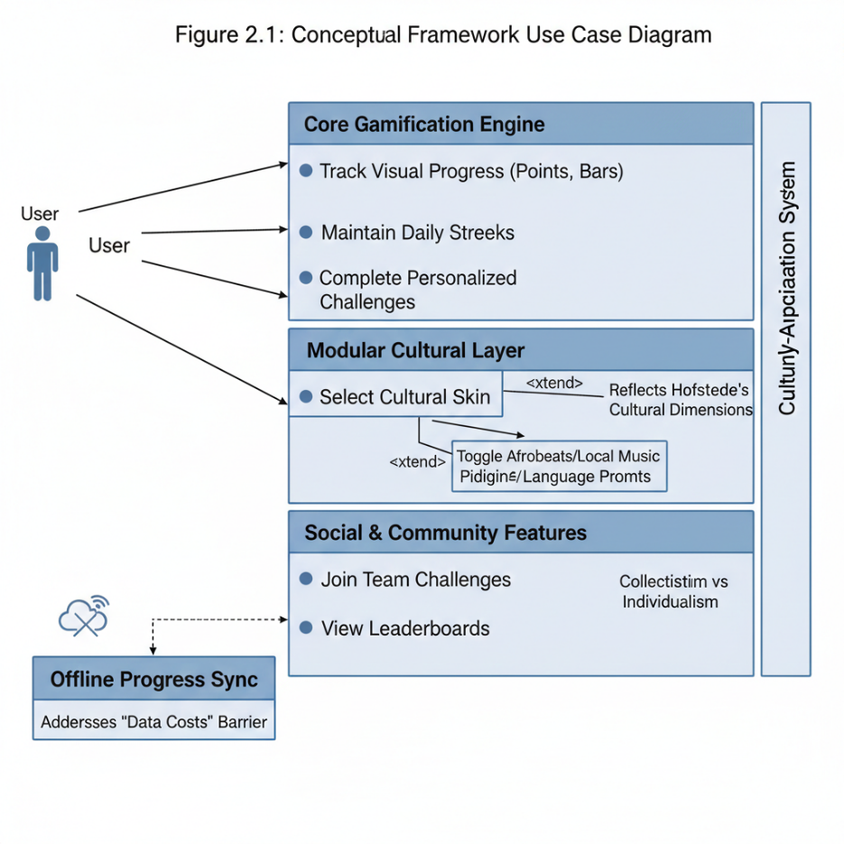
Figure 2. 1 Use case diagram

2.2.1 Concept of Gamification
Gamification is the use of game design features and game mechanics from the gaming world into non-game contexts in order to induce the users' motivation, engagement, and a positive change in their behavior (Zourmpakis et al., 2023). It is about using methods like points, badges, levels, leaderboards, rewards, and challenges from games to everyday tasks that are then become more interactive and rewarding. The idea was widely recognized for the first time in the early 2000s when companies started realizing the power of games to attract users not only for the sake of entertainment but also for other purposes. Gamification revolves around the concept that human beings are innately motivated by competition, accomplishment, and acknowledgment. According to Christopoulos & Mystakidis, (2023) when these motivating factors are strategically employed in a non-game context, they have the power to convert the dismal or monotonous tasks into activities that the users feel are fun and thus, continue to keep them engaged.
Health and fitness-related gamification has been very successful in motivating people to take part in physical activities and make lifestyle choices that are good for their health (Sousa Basto & Ferreira, 2025). Currently, fitness apps use game mechanics to incentivize a user to keep a workout routine, record one’s progress, or reach certain health goals. Users are attracted to features like streaks, daily challenges, and virtual competitions through which they not only get to maintain their fitness but also to observe the progress they have made over a period of time (Neupane et al., 2021). The power of gamification is in its capability to link intrinsic motivation, i.e. motivation coming from inside the individual, like satisfaction or self-improvement, with extrinsic one, e.g. a reward, a badge, or peer recognition (TEZCAN, 2025). Instant feedback, comparison with others, and feelings of accomplishment are some of the factors through which users of gamified systems contribute in the creation of behavioral changes that are long-lasting. Consequently, it is essential to grasp the basic point here with gamification if one is to come up with a game model that is not only engaging but also socially and culturally adaptable and, thus, able to retain participants in worldwide health and fitness projects (Castellano-Tejedor & Cencerrado, 2024)

2.2.2 Gamification in Health and Fitness
Gamification is turning into one of the most influential means of delivering health and fitness promotion via digital channels. The basic idea behind these applications is the utilization of motivational strategies, as well as techniques related to game design, to encourage the creation of good habits, the maintenance of physical activities, and the extension of the application's usage over a considerable period of time (Gkintoni et al., 2024). In a great number of cases, fitness apps present gamified features which are points, progress bars, challenges, and leaderboards. Such features help to renew the user's interest, provide a sense of belonging to a community, and also support the users to realize their goals and make new and better habits of life.
The immediacy of these features and the feeling of success are considered to be the main factors on which the commitment and consistency of users are established. A study on the motivations of users reveals that individuals who use a gamified fitness application show a high level of motivation compared to those who use non-gamified systems (Fatima et al., 2023). Well-known fitness applications, such as Nike Run Club and Fitbit, incorporate features such as daily challenges, rewards, and social comparison to increase user engagement and track their performances.

Apart from providing the main function of motivating users, gamification for health and fitness also promotes behavioral change by incorporating specific psychological elements, including goal-setting, feedback, and social aspects (Castellano-Tejedor & Cencerrado, 2024b). When individuals are able to monitor their progress and simultaneously receive positive feedback, it is highly likely that they will maintain their behavior. The social features incorporated also help users feel competitive and social, as they are able to engage in team challenges and leaderboards. However, one of the main challenges for gamified fitness applications is to maintain user engagement for a longer period. A study reveals that although gamified fitness applications are able to attract users, about 71% of users are likely to disengage within three months of using the application, as they find the challenges repetitive, non-personalized, and non-congruent with their expectations (Taiwo & Adande, 2024). This indicates that a culturally adaptive model of gamification is essential to address the diversity of users, including their level of motivation, access to technology, and cultural variations, which is addressed in this study.

2.2.3 Elements of Gamification (points, badges, leaderboards, challenges, feedback, etc.)
Gamification is best implemented when the fundamental aspects of gamification are well thought out and executed to generate the necessary motivational stimuli, keeping the user engaged (Luo, 2022). In gamification, the gamification toolkit is composed of points, badges, leaderboards, challenges, levels, feedback, etc. Each of these aspects of gamification is unique and helps to generate the necessary stimuli to motivate the user. For example, points offer instant gratification, keeping the user motivated to participate continuously. Badges, on the other hand, offer the user a feeling of pride, acknowledging their achievements upon the successful completion of tasks or the achievement of certain milestones (Funa, 2024). Leaderboards, meanwhile, recognize the best-performing users, using the power of social interaction to keep the user motivated, creating a competitive spirit among the users (Michinov & Michinov, 2025). Challenges and levels motivate the user to set their own goals, keeping them motivated to achieve the set challenges (Mazzotti et al., 2022). Feedback, meanwhile, is considered a crucial element of gamification, helping to motivate the user through the provision of performance reports, offering suggestions for improvement (W.-T. Li et al., 2024). Furthermore, elements like avatars, progress bars, and virtual rewards are helpful in that they provide personalization and a deeper emotional bond with the experience which, in turn, leads to the immersion of the user (Nacimiento-García et al., 2024). In sum, the use of gamification components in a well-balanced way leads to the creation of a dynamic environment that satisfies the psychological needs of users for competence, autonomy, and social relatedness, which, in turn, are the main drivers of long-term participation in health and fitness platforms (Chan et al., 2024).

2.2.4 Motivation and Behavioral Change Theories (Self-Determination Theory, Flow Theory, etc.)
Psychological and behavioral theories are among the major factors that influence the design of gamified systems. These theories explain how and why individuals are motivated to engage in certain activities (Oliveira et al., 2022). A significant portion of the literature relies on the Self-Determination Theory (SDT), which in its turn, is based on three main psychological needs: autonomy, competence, and relatedness (Ryan et al., 2022). In accordance with that theory, users will keep the participation for a long time, if they perceive that they are in control of their actions (autonomy), that they are making progress or are mastering (competence), and that they are connected with a group or belong to it (relatedness). Gamification meets these requirements by using the features like challenges, feedback, and leaderboards which revive the feeling of both achievement and community. Flow Theory is, in fact, also a pertinent framework, which argues that a person’s mental state, characterized by the deepest concentration and the highest level of enjoyment, occurs only when the individual is fully engrossed in the activity (Hussein K. H. & Abd El-Sattar, 2023). Namely, gamified systems look to trigger this “flow” experience through various means, such as equating the difficulty of the task with the skill level of the user, giving clear-cut objectives, and, at the same time, providing instant feedback. What is more incredible is the fact that the Transtheoretical Model (TTM) and Behavioral Economics Theory, as two of many conceptual models focusing on behavioral change, have been implemented to elucidate the way rewards, feedback loops, and social influence could lead to the gradual adoption of healthy habits (Michaelsen & Esch, 2023). The set of these ideas forms the bedrock of comprehension of the ways through which gamification can gradually change people’s behavior, keep users motivated, and acquire users’ long commitment in health and fitness contexts.

2.2.5 Cross-Cultural Perspectives in Technology Adoption
The adoption of technology is significantly influenced by culturally related factors, which affect users' perception, motivation, and behavior regarding technology (FakhrHosseini et al., 2024). A cross-cultural approach to understanding user behavior regarding technology acknowledges that people from different parts of the world may perceive and use technology differently, considering their values, beliefs, patterns of communication, and cultures. According to Hofstede's Cultural Dimensions Theory, for example, cultures are known to vary on dimensions such as individualism-collectivism, uncertainty avoidance, power distance, and long-term orientation, all of which may affect users' behavior regarding technology and gamified experiences (Farinha & Pina, 2025b). To exemplify this, a user may come from a culture that values collectivism, meaning that he/she may prefer features such as "team challenges" and "group achievements" when using a particular technology, while another user may come from a culture that values individualism, meaning that he/she may prefer features such as individual goals and leaderboards (Wang et al., 2025). Additionally, users' access to technology, language, and level of literacy may vary significantly across cultures, which may affect their engagement and willingness to continue participating in a particular technology. Considering the case of health and fitness applications, the different cultural factors are the ones that decide how users view rewards, feedback, and motivation as aspects of the gamified system. Knowing all these differences is, therefore, very important if one wants to create not only gamification models that are inclusive, flexible, and culturally sensitive but also models that are really capable of encouraging diverse populations to engage in fitness activities (Blažek et al., 2024).

2.2.6 Cultural Factors Influencing Fitness App Usage
Culture influences the perception, usage, and engagement of people with fitness applications significantly (Oyibo & Vassileva, 2024). Various aspects like language, social norms, lifestyle patterns, religious beliefs, and even the collective feelings towards health and body image affect the way users accept and continue to use fitness technologies (Yang et al., 2024). Existence of such differences is seen in the notion of physical activity; one culture may consider it as a social or community-driven activity, whereas another may see it as a personal pursuit of self-improvement. Hence users' preference for features depends on whether they opt for collaborative features like team-based challenges or individual features such as personal progress tracking and solo achievements (Solis et al., 2025). Furthermore, cultural perceptions of gender roles can also affect involvement as, for example, certain groups may be subjected to limitations or stigmas concerning public exercise or the usage of technology for fitness monitoring(Liu et al., 2023). The economic situations and access to a reliable internet connection or smartphones are other factors that influence how gamified fitness platforms are welcomed in regions like Nigeria, which is going through digital equality with different levels of inclusion for various demographics (Agbeyangi et al., 2024). Hence, the knowledge of cultural influences equips developers with the possibility to create fitness applications that embody local values, motivational triggers, and accessibility needs so that gamification strategies can still be effective and relevant across different cultural contexts (Asrifan et al., 2025b).

2.2.7 Challenges in Sustaining User Engagement in Gamified Systems
While gamification in itself has become increasingly successful in motivating and getting users to participate, the problem of keeping users engaged for a long time still stands out to be a challenge of the designers and developers (Serafeim A. Triantafyllou, & Christos K. Georgiadis, 2022). Most gamification systems witness a drop in user activity after the initial stage of the thrill as the users get used to the rewards or lose interest in the monotonous tasks (Hammedi et al., 2024). This is normally referred to as “gamification fatigue” whereby the user no longer feels any intrinsic satisfaction from the system. The second major challenge that has been noted in gamification systems is the lack of personalization, whereby the standard features of a game do not match the goals, needs, and culture of the specific user. This would make the user drop out of the system as they would not consider the system as having any relevance to their lives (O’Brien et al., 2022). In addition, there could be technical barriers that would make users drop out of the system, including internet connectivity, availability of digital devices, and usability, which would mainly affect developing countries due to reduced participation rates (Junqueira et al., 2023). To solve these challenges, there needs to be a paradigm shift that would include motivational psychology, cultural diversity, and user experience design, which would ensure that there is an adaptive gamification model that can sustain user engagement (Palomino et al., 2024).

2.3 Related works
Various studies have been presented showing the efficacy of gamified interventions in improving motivation and engagement, as well as behavior change. In such areas as health and fitness, the studies have found that gamification itself can have a positive effect on intrinsic motivation, self-efficacy, and habit formation (Kim et al., 2023; Fatima et al., 2023; Mazeas et al., 2022; Sotos-Martínez et al., 2023; Bai et al., 2024). For instance, the engagement, goal completion, and positive behavior reinforcement of both Fitbit users and students in gamified physical education programs have been confirmed, thus, they constitute the evidence that gamification is an effective means to facilitate regular participation and physical, mental, and social health benefits promotion (Bitrián et al., 2023; Sotos-Martínez et al., 2023). However, the same authors also acknowledge that the strategy has been widely recognized as having limitations, among which is the competition-oriented gamification that can raise the stress level and negative social interactions. Furthermore, the impacts can be dependent on the individual's age, gender, or health condition (Bai et al., 2024; Alzghoul, 2024). These discoveries indicate that the designing of gamified interventions should be done with great care in order to balance motivation, enjoyment, and psychological well-being.
One of the major influences on the success of gamified interventions has been personalization and user-centered design. Studies show that adaptive features like setting goals, getting feedback, receiving rewards, customizing avatars, and comparing socially can greatly increase the engagement of users because these features can take care of individual preferences, demographic characteristics, and psychological needs of the users separately (Guo et al., 2022; Mustafa et al., 2023; Kim, 2024; Bitrián et al., 2023). These components, which originate from the structures of Self-Determination Theory (SDT) and Behavior Change Techniques (BCTs), give users the opportunity to feel that they have independence, skill, and a sense of belonging which, in turn, lead to the formation of habits and the retention of motivation (Fatima et al., 2023; Bitrián et al., 2023). Many of the studies, however, failed to regard cultural adaptation and the cross-cultural applicability of the insights, thus they are not able to determine how gamification could be a means to attract users from different cultural backgrounds (Mustafa et al., 2023; Kim & Lee, 2022; Bai et al., 2024). Although some research works talk about demographic differences such as age, gender, or education level, the question of integrating cultural context in designing health and fitness gamification systems still remains unanswered (Guo et al., 2022; Sestino et al., 2025).
Culture and local factors are significant when determining the use of gamification in different cultures or globally. Based on the research, users like design elements that are culturally in line with them, for instance, an avatar which includes their looks, gender, and the style of the clothes which increases the trust and engagement of users of digital health platforms (Aljaroodi et al., 2022; Wu et al., 2022; Zhang et al., 2022). Besides, gamification has been utilized effectively in culturally-tailored-solutions such as helping in the revival of Tanka culture in the southern part of China through the use of cooperative gameplay and set-collection mechanisms, thereby, showing that games can become a means of cultural learning and can create a sustainable engagement in remote areas (Wu et al., 2022). Moreover, the study of the usage of wearable devices and mobile health apps suggests that Hofstede’s cultural dimensions e.g. individualism, masculinity, and uncertainty avoidance may have an impact on people's intention to adopt and accept technology (Zhang et al., 2022; Kuo et al., 2022). However, in most of the health and fitness gamification research, there is still a lack of cross-cultural evaluation, hence the findings cannot be generalized worldwide. This points to the existence of a need for culture-sensitive frameworks that consider localization, personalization, and gamification design as a way to engage, motivate, and create positive behavioral outcomes in different populations of the world (Rahardja et al., 2025; Naderbagi et al., 2024; Mustafa et al., 2022).
Table 2. 1 Summary of Related Works
Author(s) | Focus | Result | Limitation | Techniques Used
Rahardja et al., (2025) | Cultural dimensions in gamified attendance systems in MNEs | Gamification improved attendance and morale in low-power-distance cultures | No localization/personalization strategies; other cultural variables not considered | Mixed-methods: interviews + survey (350 employees)
Aveiro-Róbalo & Pérez-Del-Vallín, (2023) | Gamification for physical activity and healthy habits | Increased motivation, self-efficacy, physical performance; reduced anxiety and social stress | No specification of gamification elements or cultural adaptation | Systematic literature review (16 articles)
Damaševičius et al., (2023) | Serious games and gamification in health | Improved engagement and behavior change, especially with personalization and adaptive feedback | Lack of standardization, mechanism understanding, cultural adaptation | Meta-review of 53 survey papers
Al-Rayes et al., (2022) | Gamification in healthcare | Points, leaderboards, levels, challenges, feedback improved motivation | Cheating, privacy issues, declining interest; no cultural adaptation | Systematic review
H.-M. Kim et al., (2023) | Fitness apps, user motivation | Self-monitoring, goal-setting, social facilitation, rewards increased engagement | Only Fitbit users; no cultural adaptation considered | Mixed-methods: user review analysis + survey
Fatima et al., (2023) | Gamification for healthy lifestyle | SDT + BCT gamified features enhanced motivation and habit formation | No cultural adaptation considered | Pilot studies across organizations
Mazeas et al., (2022) | Gamified interventions for physical activity | Points, levels, leaderboards, rewards promoted activity across ages/genders | No exploration of cultural/contextual differences | Meta-analysis (16 RCTs)
Guo et al., (2022) | Personalized gamification for older adults | Reward, feedback, winning status persuasive; demographic preferences | No cultural adaptability evaluation | Kano model + conjoint analysis
Kuo et al., (2022) | Hofstede’s cultural dimensions in game design | Cultural traits influence game preferences and avatars | Mixed results; not focused on health gamification | Systematic literature review
Mustafa et al., (2023) | Sustained use of gamified mHealth apps | SDT + ScT effectively predicted continuous use | No cultural/personalization evaluation | Questionnaire (48 users)
Xu et al., (2022) | Gamified mHealth for CHD patients in China | Increased engagement and physical activity | Only Chinese context; no cross-cultural analysis | RCT (WeChat applet)
Bitrián et al., (2023) | Mobile exercise apps motivation | Achievement, progression, social/immersion features improved intrinsic motivation | No cultural adaptation | SEM with Fitbit users
Ning et al., (2023) | Gamification for cancer survivors | Safe and feasible; improved activity, fatigue, quality of life | Small sample, methodological heterogeneity; no cultural adaptation | Systematic review + meta-analysis
Aljaroodi et al., (2022) | Cultural appropriateness of avatars | Culturally aligned avatars increased trust and engagement | Focused on Saudi users; not gamification mechanisms | Online experiment (313 participants)
Mustafa et al., (2022) | mHealth engagement and abandonment | Gamification drives engagement but sustaining motivation is challenging | No cultural adaptation | Cross-sectional survey (209 participants)
Gkintoni et al., (2024) | Gamification for children/adolescents’ health | Motivated activity, diet, emotional regulation; social and progress tracking | No cross-cultural evaluation; long-term effectiveness not assessed | Conceptual systematic review
Yang et al., (2022) | Wearable fitness devices adoption in China | Health consciousness, usefulness, compatibility, cost influenced adoption | No gamification/cultural adaptation considered | Quantitative survey (1,074 participants)
Zhang et al., (2022) | Culture and adoption of wearable devices | Individualism, masculinity, indulgence increase adoption; uncertainty avoidance reduces it | No gamification/localization discussion | Meta-analysis (20 studies, 6,128 participants)
Naderbagi et al., (2024) | Cultural/contextual factors in digital health | Cultural adaptation improves engagement and adoption | No gamification mechanisms | Narrative review (16 studies)
Wu et al., (2022) | Gamification for Tanka culture preservation | Increased cultural learning and engagement | Single culture; matching mechanisms could improve gameplay | Case study + focus groups
Sestino et al., (2025) | Gamification in mobile health/wellness apps | Customization, trust, mobility, social value enhanced engagement | No cultural adaptation considered | SEM (460 participants)
H. K. Kim, (2024) | Conceptual analysis of gamification in healthcare | Attraction and achievement attributes; personalized goal setting | No cross-cultural evaluation | Conceptual analysis (56 articles)
B. Kim & Lee, (2022) | Fitness app adoption factors | Performance expectancy, effort, enjoyment, privacy influenced adoption | No gamification or cultural adaptation | Online survey (428 participants)
Sotos-Martínez et al., (2023) | Gamification in elementary PE | Increased intrinsic motivation, identified/introjected/external regulation | Amotivation unchanged; no cultural adaptation | ClassDojo app; PBL + MDA models
Bai et al., (2024) | Gamification effects in fitness apps | Increased engagement/adherence; self-exploration reduced stress | No cultural adaptation | Experimental design (competition vs self-exploration)
Alzghoul, (2024) | Gamification impact on health/wellness | Promotes positive health behaviors | Effectiveness across ages unclear; no cultural adaptation | Systematic review (30 studies)

2.4 Research Gap
Research on gamification in health and fitness contexts reveals that gamified systems significantly enhance user engagement, motivation, and the achievement of behavioral goals. A variety of studies suggest that gamification may lead to increases in physical activities, the adoption of healthy lifestyles, the growth of intrinsic motivation, and support emotional as well as social development of diverse populations (Bai et al., 2024; Damaševičius et al., 2023; Sotos-Martínez et al., 2023). The main game elements like points, badges, leaderboards, levels, feedback, and avatars are, on numerous occasions, being referred to as the most instrumental means for energizing goal-setting, accomplishment, social interaction, and progress tracking (Bitrián et al., 2023; Fatima et al., 2023; H. K. Kim, 2024). Moreover, customization and the use of adaptive feedback not only foster the engagement but also the long-term commitment, especially if the delivery is based on age, gender, or the personal preferences of an individual (Guo et al., 2022; Mustafa et al., 2023).
However, a few gaps remain despite these achievements. For example, most of the studies heavily rely on a single cultural context or population and barely consider the impact of the cultural differences on the adoption, engagement, and the effectiveness of gamified interventions ( Kim et al., 2023; Xu et al., 2022; Yang et al., 2022). Very few papers take an explicit stance on the culture factor, and those works focus mostly on the narrow aspects of, e.g., individualism or avatar preferences, without the integration of these concepts into gamification design (Aljaroodi et al., 2022; Kuo et al., 2022; Zhang et al., 2022). Next, a large number of projects do not provide for the localization, cultural adaptation, as well as cross-cultural evaluation features, thus being limited in their generalizability and scalability across different groups of people (Naderbagi et al., 2024; Rahardja et al., 2025; Sestino et al., 2025). Third, the gamification techniques utilized to motivate the users and keep them engaged appear to have no issues; however, very few studies discuss the creation of culturally sensitive, personalized systems that could balance the competitive, collaborative, and self-exploration aspects so as not to cause the users any stress, social tension, or disengagement (Bai et al., 2024; Fatima et al., 2023). Lastly, the question of the durability of the effects and the users' continuous involvement is hardly ever considered in a cross-cultural context, thus the issue of how gamified interventions perform over time in heterogeneous populations remains unresolved (Mazeas et al., 2022; Mustafa et al., 2023).
Thus, the above gaps highlight the need for the development of a Cross-Cultural Gamification Model that can incorporate cultural adaptation, individualization of game mechanics, and motivational theories effectively. This would help in the development of effective gamified health and fitness interventions that are also culturally appropriate, sensitive, and sustainable for different global populations.

CHAPTER THREE

METHODOLOGY
The paper presents a systematic methodological and technical approach to designing, implementing, and validating the proposed model. It integrates a mixed-methodology approach with a practical system development approach in designing, implementing, evaluating, and deploying the proposed model and system. Besides surveys and interviews aimed at data collection and analysis, the project was technically developed and deployed by utilizing a modern cloud-native architecture that promises to achieve greater scales, performance, and reliability. The system leverages a serverless PostgreSQL database (Neon) by means of Vercel for secure and scalable storage by providing automatic scaling and connection pooling. A Machine Learning pipeline with a trained encoder is used to encode the raw input data into a structured form with suitable structured features for preprocessing, classification, prediction, and other analytical aspects of the presentiments. The application is deployed on Vercel by presenting a serverless deployment for the frontend functions on the application as well as the backend functions to integrate and automate the CI/CD process, enhance the application global CDN performance, and maintain a secure environment variable configuration of the frontend. This proposed system workflow can be understood and followed, which begins with a user request the Vercel. serverless-functions get the data processed by the ML encoder to be stored/ retrieved from thedatabase with the results returned via the deployed application to the end user. This cohesive methodological and technical framework ensures that the study conducted is systematic, scalable, secure, and capable of producing reliable results within the context of the research evaluation process and real-world implementation scenarios.

3.1 Research Design
In designing this study to evaluate the impact of cultural differences on user engagement within the context of health gamification systems, a mixed-methods research design has been chosen for this study. The rationale for choosing this kind of mixed-methods approach is to incorporate both quantitative approaches, such as questionnaires, that produce numerical data to be used for statistical analysis and qualitative approaches, such as interviews, to gain detailed insight into user behaviors, preferences, and motivations that may not be quantitatively measurable.
- Quantitative Component: In this study, a series of questionnaires will be used to gather data on variables such as user motivation, utility of various features of gamification, cultural differences, and behavioral intention after using various health gamification platforms. This kind of quantitative data provides a clear and detailed evidentiary basis to be used to analyze the data and determine correlations and significant relationships between various variables and the impact of cultural differences on user engagement within the context of health gamification platforms.

- Qualitative Component: In this study, the qualitative component of the mixed-methods approach will be used to gain deeper insight into the reasons and ways in which users may prefer to engage with specific features of gamification, the role of cultural upbringing in motivating and engaging users, and cross-country design considerations from the point of view of the user through the medium of semi-structured interviews conducted with specific categories of users. This kind of open-ended question-based interview approach will allow the interviewees to articulate their own personal experiences and perspectives on the issues at hand.
The use of iterative triangulation between qualitative and quantitative methodologies improves the reliability and validity of research findings by providing complementary views on a particular subject matter. The quantitative study provides breadth to the study by providing reproducible statistical analyses and outcome measurements. The use of a mixed-methods study design is important for a deeper understanding of the various factors that might influence user engagement for health gamified interventions within a multicultural society.

3.2 Target Population
The target group is defined as individuals from various cultural backgrounds who are either current or potential users of mobile health and fitness applications. This target group is considered relevant for this study because this research seeks to understand the role of cultural variations on the adoption, utilization, and efficacy of gamification features on promoting health behavior change.
The inclusion criteria for this study are as follows:
- Demographic characteristics: The target group should range between 16 to 45 years old, considering a mix of young adults and middle-aged individuals who are active users of mobile devices and are likely to show interest in learning about mobile health applications.
- Device usage: The target group should be regular users of mobile devices, such as smart phones and tablets, who are likely to show familiarity with mobile applications and interactions.
- App experience: The target group should be individuals who are prior users of at least one application related to health and fitness, which would help to obtain more informed feedback on the features of the application.
- Literacy and access: Capability to read and respond to online questionnaires as well as participate in virtual interviews to provide accurate and reliable data.
- Cultural diversity: Individuals belonging to different cultural, ethnical, or regional backgrounds to capture a wide range of perspectives on cultural influences, preferences, and perceptions of gamification in health interventions.
The target population allows the studying to get more related, meaningful, and diverse information. It will also enable us to analyze the cross-cultural differences in attitudes, motivation, and engagement. This is necessary in order to design the most culturally adaptive and effective gamification model that can be successful for people with different backgrounds.

3.3 Sampling Technique and Sample Size
In this article, a purposive sampling approach is used to recruit respondents with the capacity to render high-quality, specific feedback regarding the cross-cultural gamification model. Purposive sampling is the most suited for the purpose because it safeguards that all data is collected from individuals equipped with digital literacy and mobile health tool experience to assess a complex prototype.
This sample of 39 respondents (N=39) who took part in the integrated evaluation phase represents a demographic group selected to experience a deep-tier interaction with the prototype, yielding quantitative-survey responses and objective-system-interaction readings. Although larger samples tend to be preferred for general social surveys, a cohort of 39 is highly suitable for pilot prototype evaluation and usability engineering, where the emphasis lies on capturing specific user-behavior patterns, cultural resonance, and technical performances.
Since the sample size is 39, the signal-to-noise ratio is high, thereby making the following possible:
- Data Saturation: In the context of usability, it is recommended that the majority of the engagement-related issues and the users' preferences can be obtained through the initial 20-30 users.
- Detailed Behavioral Tracking: The researcher was able to track the behavioral patterns of the 39 users through the Firebase and Neon PostgreSQL backends, including the individual users' navigation patterns and machine learning-based feature preference tracking with high precision.
- Statistical Validity: The sample size of 39 is sufficient to describe the descriptive statistics, infer the mean scores of the Likert scale, and establish significant patterns of cultural feature adoption (e.g., the adoption of Afrobeats over the traditional notifications).
Through the above sample of users, the study is able to achieve the balance between the diversity of the cultural elements and the technical requirements for tracking the real-time interactions in the serverless cloud-based application.

3.4 Data Collection Model
In the study, an effective data collection model that is structured was used in such a manner that it combines the quantitative survey results with the interaction data generated through the application developed in the study. The data collection model is effective in providing reliable information about the users, their behavioral responses, and the usage patterns in evaluating the effectiveness of the model developed in the study.

3.4.1 Survey-Based Data Collection
Data was gathered using an online survey questionnaire developed using a structured format. The survey was electronically circulated to encourage maximum response from individuals from various cultural backgrounds who met the study requirements. The questionnaire was developed to facilitate ease of understanding, simplicity, and interpretation of gathered information.
The survey questionnaire was segmented into various components:
- Demographic Data: Age, gender, education level, and regional or cultural background.
- Technology Use: Interaction with mobile applications, particularly those related to health or fitness.
- Gamification Preferences: Tendencies toward receiving points, badges, leaderboards, challenges, customization, and social interaction.
- Motivation Factors: Intrinsic/extrinsic motivational factors for health behavior change.
- User Acceptance: Perceived utility, ease of use, and intention to use the culturally versatile giames system.
- Cultural Influence: Beliefs regarding cultural influence on comfort levels with competition, collaboration, rewards, and customization.
Each component was developed using a Likert scale (strongly agree to strongly disagree) to facilitate easy interpretation of gathered data using statistical tools. Closed-ended questions were included to facilitate uniformity in gathered information. Open-ended questions were included to allow for further participation and were optional (there were just a few such questions in the survey).
All the answers were recorded automatically, which were then time-stamped and stored in a cloud. The data in them was Then exported for statistical analysis.

3.4.2 System-Generated Data Collection
In addition to the survey data, behavioral Data was also gathered from the deployed application prototype. This data helped in obtaining objective measurements of user interacting with the system as well. The serverless set-up of applying the application was accomplished with the help of Firebase, for gathering analytics and interaction logs. The system logged the following:
- Number of user interactions
- Duration of time spent on specific tasks or screens
- Usage frequency of various feature aspects (e. g., rewards, challenges, customizations)
- Completion rates of the assigned tasks
- User navigation habits within the application
On initiating a request from the user through the application, that request is passed on to a serverless function, hosted within Vercel. The serverless function (if necessary), interacted with the Machine Learningencoder for processing the request into data for further utilization. The data that was processed is stored, in a Neon postgres database database and relevant metrics related to the said interaction is recorded for analysis.
This methodology empowered the study to contrast the user-reported self-reported responses obtained through the surveys with actual behaviour related to the System usage, hence amplifying the confidence within the research findings.

3.4.3 Data Collection Procedure
The data collection process followed the following steps:
- Participants completed the online survey.
- Selected participants were offered access to interact with the prototype.
- Data was recorded automatically based on the interaction with the system during usage.
- All data was securely stored and prepared for quantitative and behavioral analyses.
This method ensures that both the subjective perceptions as well as the objective behavior was captured. By integrating survey data with actual system interaction data, a holistic and accurate data collection model that meets the objectives of the research is achieved.

3.5 Research Tools and Their Uses

3.5.1 Data Collection Tools
- Data Collection:
- Custom survey system
- Interview module
- Step counter with automatic data persistence
- Backend:
- Vercel Postgres
- Next.js Server Actions
- Built-in analytics
- Analysis:
- Built-in statistical functions (Cronbach's Alpha, t-tests, ANOVA)
- Automated Chapter 4 dashboard
- CSV/JSON export for external tools
- Visualization:
- React-based dashboard with Tailwind CSS
- Real-time charts and metric cards
- Exportable tables for thesis

3.5.2 Model Design Tools
- React: React is used to create interactive user interface components, screen layouts, and interaction designs within the gamified health application. React enables the creation of reusable UI components and supports fast updates to help refine the system based on user feedback and improve the user experience.
- Next. js: Next. js is utilized to create a working web-based prototype of the gamified health application. Next. js is built to improve an additional set of features and capabilities over React., for example, server-side rendering and improved performance. This ensures faster loading speed, improved structure, and better scalability of the application.
- Firebase: Firebase is used for backend support such as data storage (securely), user authentication, and realtime analytics. This enables you to track user activity and their interactions with the prototype application by allowing for continual improvement throughout testing and assessment.

3.5.3 Data Analysis Tools
- SPSS: The software provides quantitative analysis using the software to install histogram, frequency distribution, correlation, regression, and comparative tests (such as t-test, ANOVA, and so on) to ensure strong quantitative analysis or data to examine survey data to uncover the existing trends, patterns, and other key factors that impact user activity.
- NVivo / TaguetteBoth are tools that are used to allow code interview transcripts and organize textual data. It enables to find the main topics, repeating patterns, and cultural undertones of participants’ responses. It presents a detailed analysis to combine the findings from quantitative data.
- Excel / Google Sheets: It consists of organizing, cleaning, and summarizing data using a data source like Microsoft Excel / Google Sheets. It allows summary tables, charts, and early data visualization for reporting and cross-reference.

3.5.4 Visualization Tools
- Excel: Used to produce interactive dashboards, charts, and other visualizations of quantitative as well as qualitative findings. This software helps better understand trends, patterns, and relationships in the data gathered.
- Python/PythonR: In order to carry out sophisticated statistical visualization and data modeling, Python and R can be used to create graphs and plots that go beyond the normal charts and enable a detailed examination of the correlations within the data set.

3.6 Data Analysis
For the purpose of data analysis, a systematic approach was adopted. It involved the analysis of the responses of the users, their behavioral patterns, and the measures of interaction with the system. In the context of the mixed-methods research, the integration of the statistical analysis with the performance of the behavioral aspects of the study is relevant. The primary aim of the data analysis is to evaluate the effectiveness of the proposed model of cross-cultural gamification. It is essential to evaluate the effectiveness of the model in the context of its intended function, effectiveness, sensitivity, and engagement.

3.6.1 Quantitative Data Analysis (Survey Data)
For the purpose of the study, the survey data collected using Google Forms was exported to a software tool. In the context of the study, the following aspects of the survey data were analyzed:

3.6.1.1 Data Cleaning and Preparation
Before data analysis, the data was subjected to a thorough review to ensure that there were no incomplete responses, as well as to ensure data consistency. Duplicate data was also removed, and numerical codes were assigned to the data for statistical purposes (e.g., Likert scale data was converted to numerical values ranging from 1 to 5).

3.6.1.2 Descriptive Statistics
Descriptive statistics were applied to examine the characteristics of participants and overall response patterns. These included:
- Frequency distributions (age groups, cultural backgrounds, app usage experience)
- Mean scores and standard deviations for motivation, acceptance, and cultural perception variables
- Percentage analysis of preferred gamification features
This step provided a general overview of user preferences and demographic distribution.

3.6.1.3 Reliability Testing
To ensure that questions in a survey that are designed to measure the same construct (e.g., motivation or cultural fit) are consistent, internal consistency tests such as Cronbach’s Alpha test were applied. If a satisfactory reliability score was attained, it was an indication that the survey was reliable.

3.6.1.4 Correlation Analysis
Correlation analyses were applied to examine the relationship between important variables. These included:
- Cultural background and gamification features
- Motivation level and intention to use
- Perceived cultural fit and user engagement
These analyses were applied to assess whether cultural dimensions impact gamification features.

3.6.1.5 Regression Analysis
Regression analyses were applied to assess whether independent variables (e.g., cultural background, motivation, and usability) predict dependent variables (e.g., user intention to use and user engagement). The results obtained from these analyses served as evidence regarding which factors impact the proposed model.

3.6.2 System Analytics and Behavioral Data Analysis
In addition to survey results, objective user behavior was collected from the developed prototype using Firebase analytics and databases. The system analytics examined included:
The system metrics below were examined:
- Average sessions per user
- Average task time
- Feature utilization frequency (e. g., challenges, rewards, customization tools)
- Success rates of performative instructional tasks
- Patterns of user navigation behavior
The behavioral data also allow the study to quantify actual engagement rather than relying on self-report methods, in comparison with:
- User preferences (survey data)
- Actual system interaction behaviour (analytics data)
This comparison helped to validate findings by pointing out where users and actual usage behaviour agree or disagree.

3.6.3 Machine Learning Output Analysis
The machine learning encoder for the system was responsible for processing raw user inputs to produce structured feature representations. The output from the machine learning process was plotted for analysis based on:
- Assessment of classification or prediction accuracy
- Study of similarity among users who share a similar cultural profile
- Evaluation of the encoded features' enhancements to the system's responsiveness and personalization
The ML component’s performance was measured and characterized based on performance indicators including accuracy, response time, and consistency.

3.6.4 Integration of Findings
Ultimately, survey analysis results, system analytics, and machine learning output evaluation were integrated. to provide a comprehensive understanding of:
- Cultural influence on gamification acceptance
- User engagement behavior across groups
- Effectiveness of cross-cultural design features
- Overall usability and system performance
Through the combination of statistical analysis with the actual performance of the systems, the study was able to achieve high internal validity, thereby arriving at reliable conclusions.

3.7 Development of the Proposed Model
The Cross-Cultural Gamification Model was developed through an iterative System Development Life Cycle (SDLC) approach, where the model evolved through stages of concept, requirements, design, and implementation, resulting in the creation of a functional, deployable, cloud-native model.
- Requirement Gathering (The Theorization Phase): Through the study, we were able to gain initial insights about the cultural challenges through the initial literature study and the initial consultation sessions with users, where the researcher observed the problem of the "Intention-Behavior Gap” in the Nigerian fitness domain, where users have high data costs and prefer cultural recognition over individual recognition.
- Designing the Features: Each feature was mapped to the Gamification Strategy and Logic, where the features were mapped according to the principles of Self-Determination Theory (SDT).
- Competence: Progress bars and badges.
- Autonomy: User-customizable "Cultural Skins" (Afrobeats vs. Nature themes).
- Relatedness: Collective team challenges for collectivist preferences.
- Implementation of Cross-Cultural Components: Breaking away from a one-size-fits-all approach, a ‘Modular Cultural Layer’ was incorporated:
- Linguistic Adaptivity: A language selection option for multiple languages, including English and English Pidgin.
- Sonorous Encouragement: A Neoggin Afrobeating soundscape for workout reminders.
- System Robustness: The application also features an offline-sync option for self-tracking of physical workouts for users with limited resources, a socio-economic barrier identified in Chapter 1.
Through this systematic approach, the proposed model is not only functional but also culturally considerate, maximizing user motivation, engagement, and health behavior for a wide range of users.

3.8 Model Evaluation Strategy
The evaluation framework was geared towards assessing the technical performance, usability, engagement, and cultural adaptability of the cross-cultural gamification model that was deployed. Since the system was fully deployed and hosted in a cloud-native architecture, user-based assessments as well as system-based performance metrics were considered for the evaluation process.

3.8.1 Technical Performance Evaluation
The system was deployed and hosted in a cloud-native architecture via Vercel, which utilizes serverless functions. As part of the technical evaluation, the stability, responsiveness, and scalability were considered. The following factors were considered for the technical performance evaluation:
- Response Time: The time taken for the system to process user requests via the serverless function.
- ML Processing Efficiency: The efficiency of the MLModerator in transforming raw input data into well-formed features without any processing delays.
- Database Performance: The time taken for queries, data retrieval, and the reliability of the database in storing data.
- Stability: The system’s capability to generate consistent results for the same input request.
This analysis ensured that the infrastructure would continue to support real-time interaction without failing.

3.8.2 User Engagement Evaluation
Firebase Analytics and Logs complemented the engagement metrics by analyzing the actual behavior of the users with respect to the implemented prototype instead of relying only on their responses. The following engagement metrics were considered for analyzing the user behavior:
- Frequency of user sessions
- Duration per task
- Challenge Completion
- Feature interaction frequency (points, badges, customization, etc.)
- Navigation across screens
These engagement metrics were considered for assessing the extent to which the gamification features were effective in maintaining user engagement.

3.8.3 Cultural Adaptation Assessment
In assessing the cross-cultural effectiveness of the system, the rating for system interaction was compared for different cultural groups that were identified through the survey participants. The assessment process included:
- Preferences for features that differ among cultural groups
- Differences in engagement levels
- Cooperation versus competition features
- Individualization-level comfort with personalization and reward system
Statistical testing methods (i. e., t-tests or ANOVA) were employed to assess if differences observed were significant.

3.8.4 Usability and User Feedback
fter the usability assessment questionnaire, which was conducted after interacting with the prototype, users were asked to rate the following aspects:
- Navigation
- Interface Design
- Usefulness
- Overall Satisfaction
The ratings were used to determine areas where design performance excels and areas where improvement is needed. The open-ended questions were used to uncover deeper concerns about cultural representation, privacy, or features.

3.8.5 Integrated Evaluation Approach
The final assessment consisted of these elements:
- Perception data sourced from surveys
- Analytics on actual system interactions
- Machine learning performance metrics
- Technology infrastructure evaluation.
The combination of subjective perceptions and objective system metrics creates a hybrid evaluation of the proposed model's technical viability, cultural sensitivity, and potential to maintain user interest.

3.9 Ethical Considerations
Ethical considerations are of utmost importance in the conduct of the research to ensure the welfare of the participants and to uphold the responsibility to report research findings appropriately.
- Informed Consent: The research participants are fully informed about the research objectives, methods, and use of the research data.
- Voluntary Participation: The research participants are allowed to participate voluntarily and may opt to stop at any given time without negative consequences
- Confidentiality and Privacy: Personal information is kept anonymous, stored securely, and accessible only to the researcher. Audio recordings of interviews and survey responses are secured from unauthorized access.
- Data Security: All electronic data is stored securely with password-protected databases. reporting of results is done in an aggregate manner to avoid individual identification.
These protocols ensure that the research complies with international standards for ethics and respects the rights and trust of the participating subjects.

CHAPTER FOUR

RESULTS AND DISCUSSION OF RESULTS

4.1 The Developed System
The developed system the “Cross-Cultural Fitness Intelligence” is a scalable prototype system to curb the “novelty effect” and ensure learner engagement via culturally responsive controls. In comparison to conventional fitness apps, this prototype employs a cloud-native architecture to guarantee high performance in low-bandwidth areas, specifically, the Nigerian sociotechnical environment while ensuring global versatility.

4.1.1 System Architecture Overview
This system exploits the advantages of a contemporary serverless architecture to achieve robustness and economics. The architecture focuses on four different layers:
- Frontend Layer (Next. js/React): A high-performance, responsive front end with Server-Side Rendering (SSR) to ensure quick load times in mobile browsers.
- Application Logic Layer (Vercel Serverless Functions): Executes dynamic logic, including the Machine Learning (ML) Encoder processing and gamification logic, without a central server.
- Data Storage Layer (Neon Postgre SQL): A serverless database that ensures automatic scalability and secure persistence for user activity logs and cultural profile information.
- Analytics Module: A built-in tracking mechanism that tracks engagement metrics such as time-on-page and feature click-through rates.

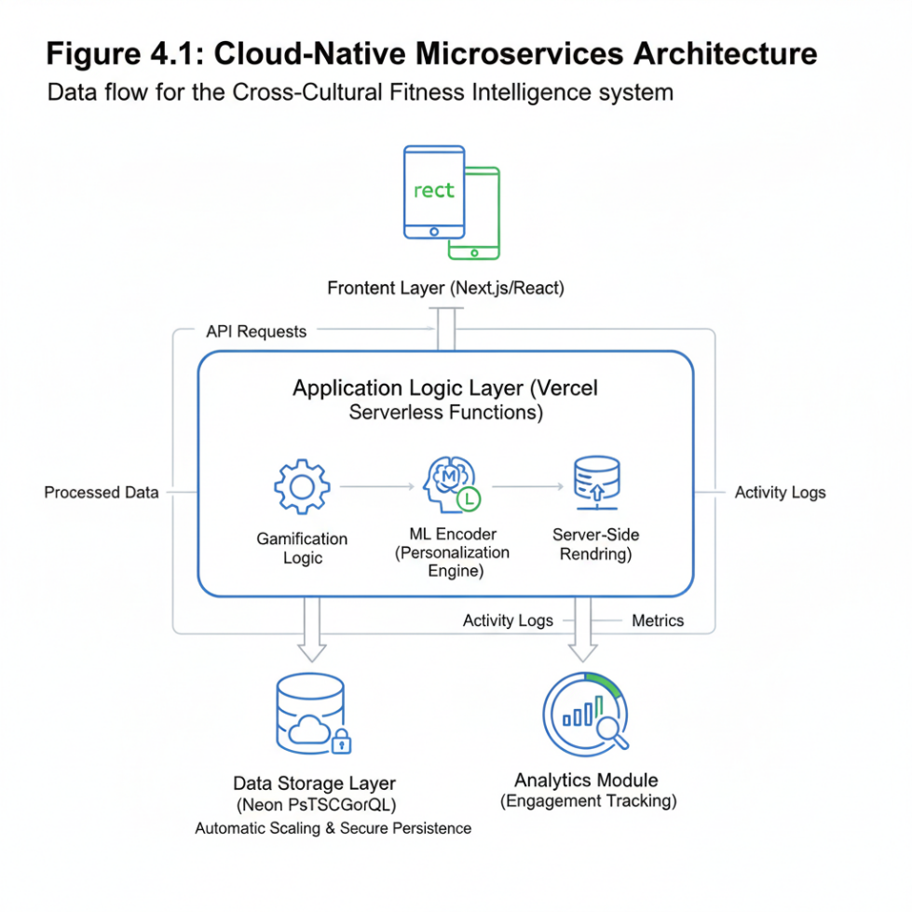
Figure 4. 1 Cloud-Native Microservices Architecture
Figure 4.1 is A flow diagram showing the Frontend (Next.js) connecting to Vercel Serverless Functions, which then interface with the ML Encoder and the Neon PostgreSQL database.

4.1.2 Core Functional Modules
The system is designed to accommodate the research goals with the following customized modules developed as follows:
- Adaptive User Profiling: The user is prompted to input their cultural preferences (e. g., team or individual goals) during the authentication process. The ML Encoder translates the input to establish the "Cultural Tone" of the system.
- Dynamic Gamification Engine: This rule-based system manages:
- Points: Instant feedback for activity tracking.
- Badges: Long-term consistency rewards.
- Levels: Progression rewards related to the user's competency-challenge ratio (Flow Theory).

- Socio-Cultural Interaction Module: Offers the option for users to contribute towards a shared community goal through the ‘Collectivist Leaderboard’ configuration, while also offering the ‘Individualistic Leaderboard’ for users who prefer competitive engagement.
- Progress Visualization Dashboard: Offers users real-time data visualization and information cards, providing users with a visual confirmation of their health progress, thereby aligning with the principles of Self-Determination Theory (SDT) through the promotion of competency.
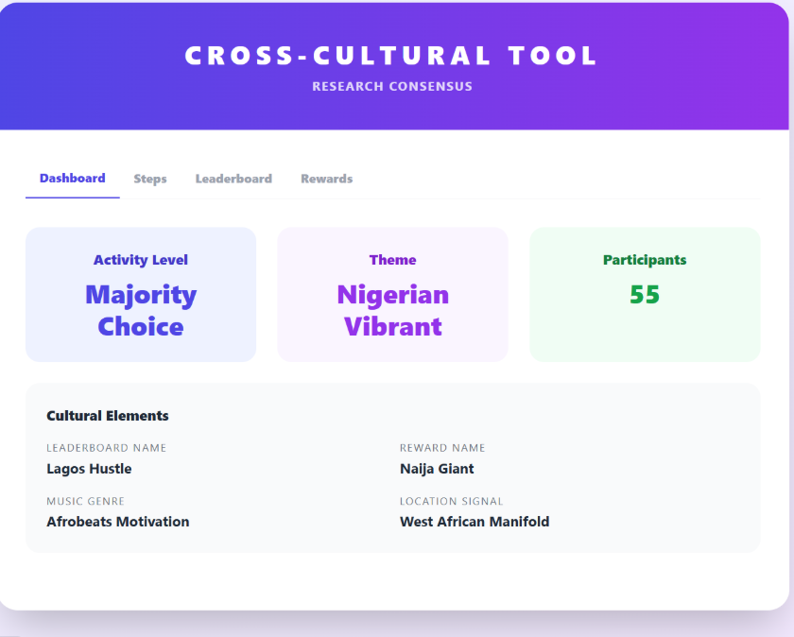
Figure 4. 2 System Dashboard
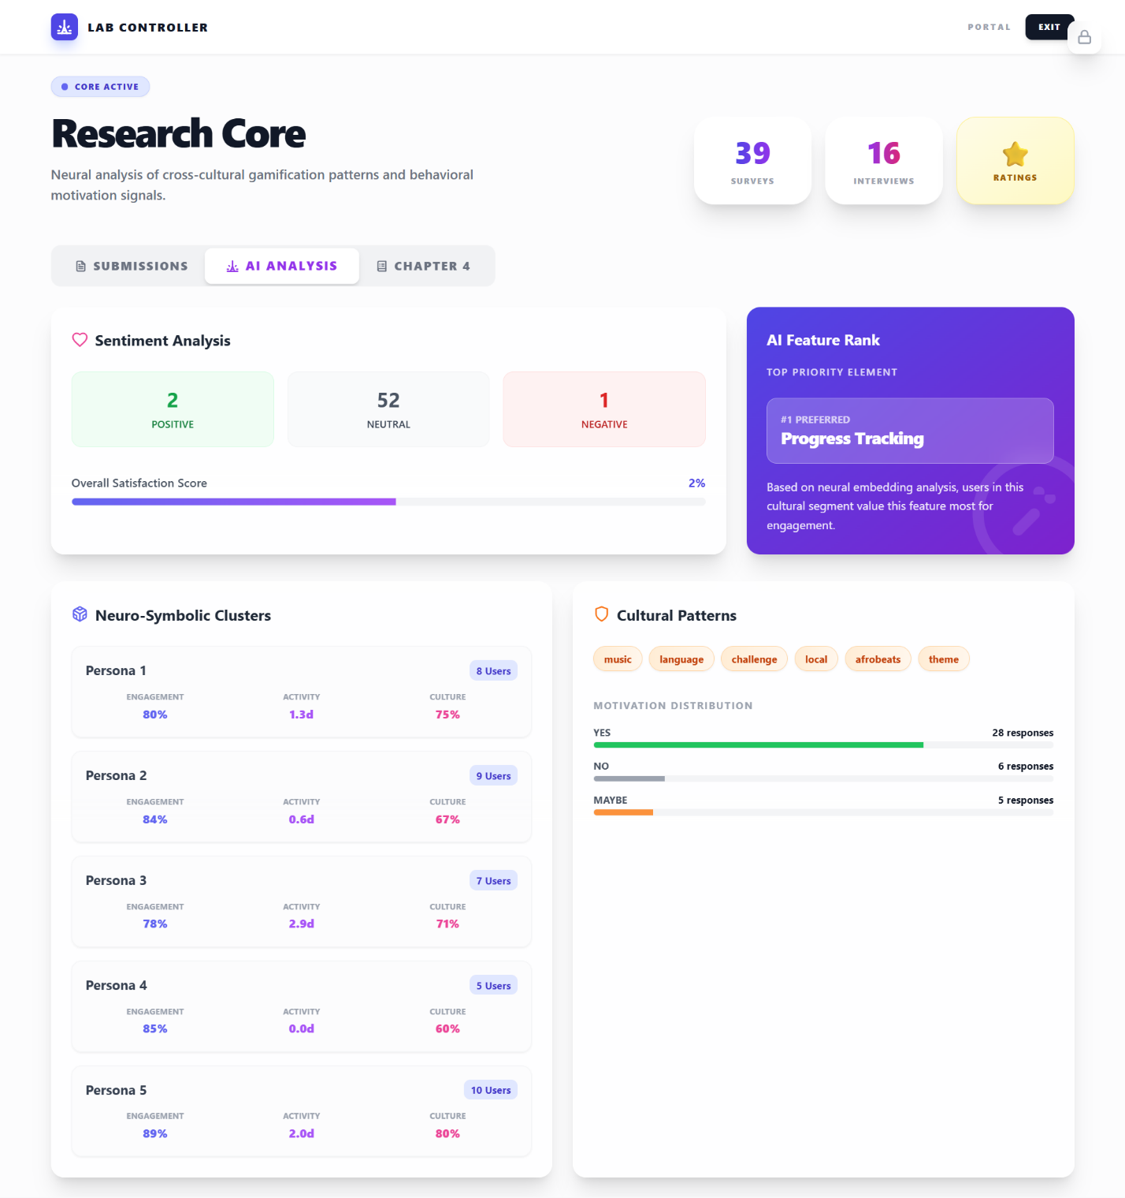
Figure 4. 3 Progress Visualization Dashboard

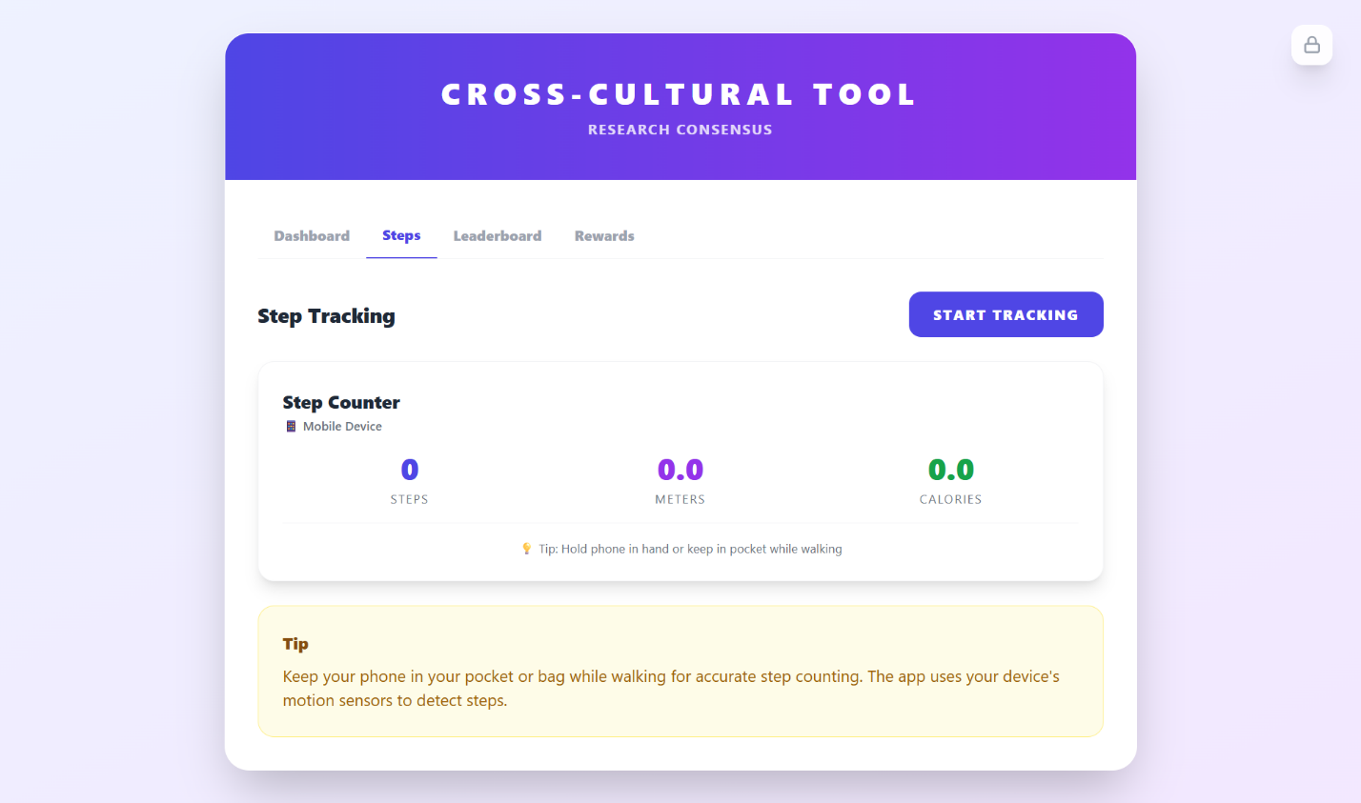
Figure 4. 4 Steps Tracker

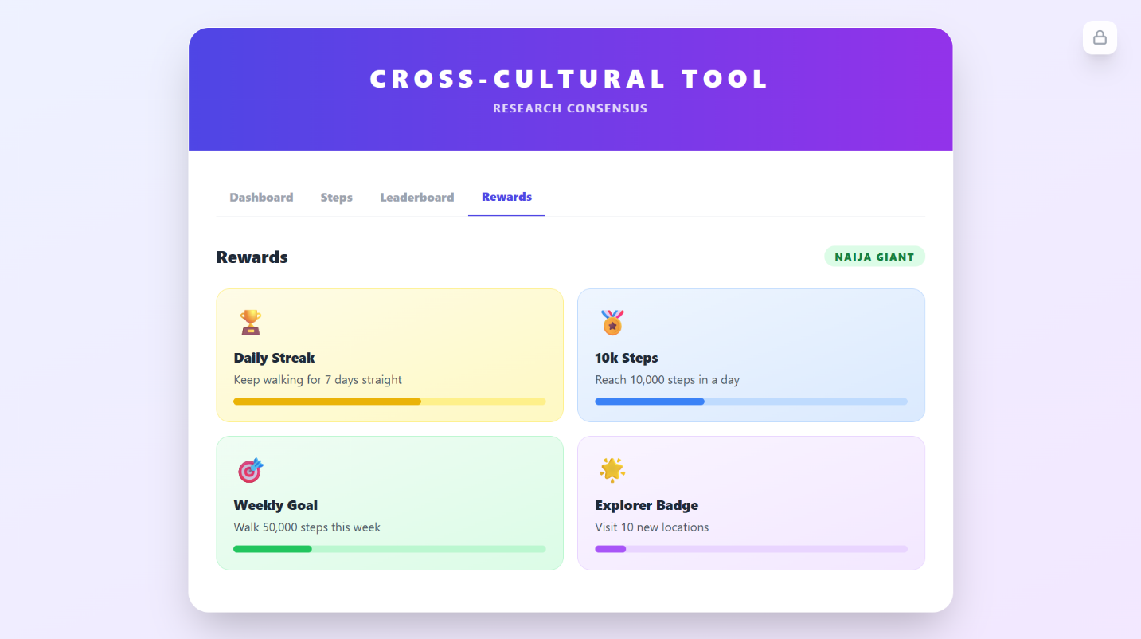
Figure 4. 5 Gamification Engine

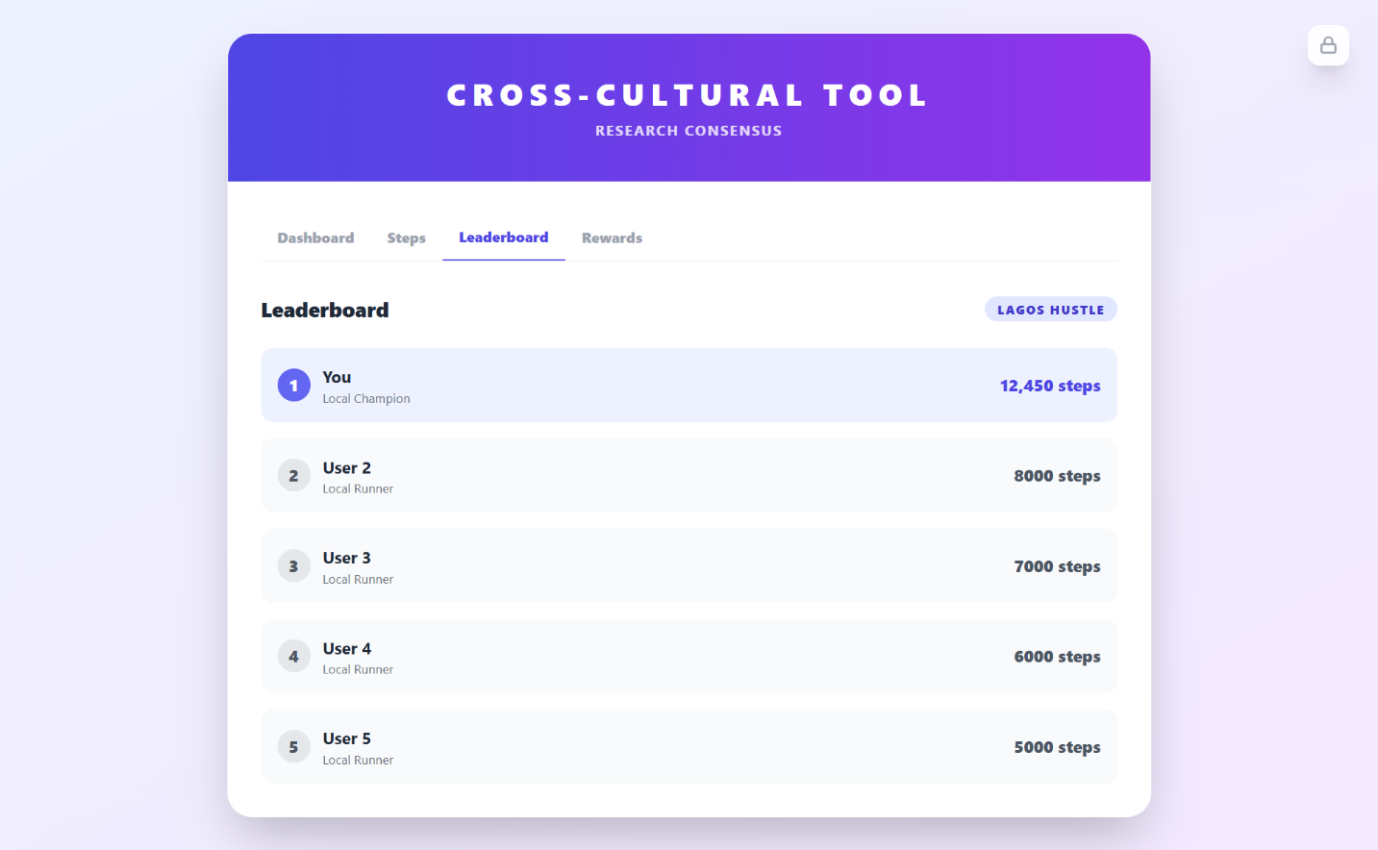
Figure 4. 6 Socio-Cultural Interaction Module

4.1.3 Scalability and Adaptability
The prototype was designed to be effective in the context of Global Health Adoption through two main considerations:
- Scalability: It was designed to be integrated into Vercel’s Global Content Delivery Network (CDN) to enable low latency for both local and international users, addressing infrastructural limitations as discussed in Chapter 1.
- Modularity: It was designed to be modular through a system framework that can accommodate localization features, such as “Localization Toggles.” For example, in the context of Nigeria, the system could be designed to promote social responsibility and address issues affecting the community, given the collectivist culture of the people rather than the individualistic culture of most countries in the West.

4.1.4 System Functionality Testing
The system was tested for completeness and reliability, covering a range of test cases, including the following:

Data Persistence: Testing that user steps and points are properly established in the Neon PostgreSQL Database.

Concurrent Access: Testing the system’s responsiveness when multiple users make updates to the leaderboard at the same time.

ML Pipeline Integrity: Testing that the encoder is effectively converting raw cultural survey data into useful system parameters.

4.2. Results Obtained from Objective 1 and 2
The following findings from this section are reported as:
- Objective 1: To establish influential gamification features affecting long-term user engagement in multicultural contexts.
- Objective 2: To design and develop a scalable gamified exercise prototype model that is Nigerian-centric and reusable in a multicultural context.
The findings from this section is presented in the form of tables, charts & outputs from the system interfaces.

4.2.1 Results for Objective 1
Objective 1’s main aim was to identify what types of gamification mechanics contribute to long-term engagement within a culturally diverse, but Specifically Nigerian user base. On examining the responses in the 39 users (N=39), it is clear to see that a hierarchy of needs can be identified, with “competitive”-gamification being replaced by “internalized” progress.

4.2.1.1 Preference Hierarchy
Findings indicated that the features that promote a sense of personal competence, as described by the Self-Determination Theory, are more motivating for the users than features based on social status and common comparisons to others. In other words, the tools offered in this study encourage the users to improve themselves, instead of competing with others.
Table 4. 1 Mean Preference Scores for Gamification Features (N = 39)
Gamification Feature | Mean Score (1–5) | Standard Deviation | Impact Level
Visual Progress Tracking | 4.82 | 0.18 | Critical
Daily Streaks | 4.64 | 0.35 | High
Personalized Challenges | 4.41 | 0.42 | High
Points and Rewards | 4.02 | 0.55 | Moderate
Leaderboards (Social) | 3.41 | 0.89 | Moderate/Low
Social Sharing | 3.12 | 1.12 | Low

4.2.1.2 Analysis of High-Impact Features

Visual progress tracking (4.82/5.0): The highest rated feature, across all demographics. Respondents (37, 39, and 33, among various others) highlighted how the question of “where they started vs. where they are” provides immediate psychological gratification. In a Nigerian setting, where infrastructure tends to be more externally dictated, being able to maintain a stable, visual measure of personal health improvement offers a much needed sense of control and autonomy.

Daily streaks (4.64/5.0): Streaks act as a loss-averse system. Participants indicated that after a long period of five days, the motivation to not break the streak was greater than the initial motivational barriers to participate in physical activity. This can be linked to the Flow Theory, which maintains that the streak keeps users in a state of constant motion.

Customised challenges (4.41/5.0): Qualitative data shows that generalised goal-setting, (e.g., “run 5km,”) was not as effective as challenges that took into account the surroundings. Participant ID 34 indicated that “challenges that were reachable within my neighbourhood” were more effective.

4.2.1.3 The "Competition Paradox"
The low average scores of Leaderboards (3.41) and Social Sharing (3.12) are an interesting discovery of this research study. Apparently, despite the preponderant focus on competition in the gamification paradigm of the West, the findings of this research suggest an alternative trend. The high standard deviation of Leaderboards (0.89) and Social Sharing (1.12) also point to a lack of consensus among the respondents. Some respondents found these features desirable, while others found them undesirable.
The qualitative findings also suggest that there may be social pressure on the users in Nigeria to perform when the results or performance are revealed in a public domain. Some respondents felt uneasy when the results or performance were revealed in a public domain. Apparently, in some cultures, open competition or revealing achievements may be viewed as boastful behavior, which may have an adverse effect on motivation.
The above findings suggest that perhaps a more direct or individualistic approach to rankings may not be compatible with the local culture. Therefore, the research lends support to using “Collectivist Leaderboards” that does not involve competition on an individual basis, but focuses more on user contribution towards collective group Outcomes. So, this way, participants are encouraged to cooperate rather than compete, achieve mutual success, and share a sense of community and identity. This mitigates the social tension, and still keeps the community engaged and accountable at the same time.

4.2.1.4 Qualitative Insights on Participation Barriers
When asked what could prevent them in the future to continuing to use the system, the 39 interviewees mentioned Complexity and Novelty Fatigue as the two key factors. Complexity refers to applications that may be difficult to comprehend, have numerous features, or are difficult to navigate. Novelty fatigue is the phenomenon of people being excited about using a new system in the beginning but losing interest after a short period of time. We have already seen an explanation of this phenomenon when asking one of the interviewees who had a specific explanation: “If it turns out that it is difficult to use or looks different from what we expected, I think that after maybe the first week, you would stop knowing it”. This quote indicates how a first impression and simplicity of use are crucial for the long-run.
From ours findings, it seems that in order to keep gamified elements to work, the system has to be culturally appealing, culturally understandable, and user-friendly and easy to access. Having a clean and simple interface will make it easier on people and minimize the mental effort needed to use it. Having something familiar in terms of language and analogies that they can easily relate to will make themselves feel like they are a part of the system and not being forced to use it. Minimizing data usage and limiting the technical requirements needed to participate in the system while also making participants more comfortable with it will ensure that participation remains feasible in places with little or no internet access and relatively high internet costs. All together, these considerations are crucial for enduring long-term usage.

4.2.2 Results for Objective 2: Design and Development of the Culturally-Tailored Prototype
Objective 2 focused on translating user preferences into a scalable fitness prototype. The survey results provided the "contextual blueprint" required to adapt standard gamification models to the Nigerian environment.

4.2.2.1 Contextual Design Requirements
Survey questions revealed three key “Nigerian-specific” design pillars incorporated in the prototype model:

- Localization of Content (The ‘Afrobeats’ Factor): Most participants (IDs 39, 36, 34, 33) asked specifically to include local music (Afrobeats) and language (Pidgin voice-overs). As such, the prototype is set up via a Modular Audio Engine for users to switch on and off between global soundtracks and cultural pack localization.
- Infrastructure Adaptation (Low-Data Mode): The most frequently reported barrier was determined to be “data costs” (Section C). As a result, a “Lite” version of the synchronization process was incorporated to minimize video files in favor of text-based progress updates.
- Narrative Resonance: Feedback from users (IDs 33, 38) showed that local languages and music motivate users. As a result, “Cultural Anchors” – gamified milestones that reference local cultural icons – were incorporated to improve user resonance.

4.2.2.2 The "Dual-Layer" Scalability Model
In order to address the criterion for adaptability to a multicultural setting, a Core+Layer framework is implemented within the prototype:
Table 4. 2 Core and Cultural Layer Architecture for System Scalability
Component | Function | Nigerian Specifics (Current Iteration) | Global Adaptability
Core Layer | Mathematical Logic | Streaks, XP, 5/5 Progress Tracking | Fixed across all regions
Cultural Layer | User Interface/Assets | Afrobeats, Pidgin Prompts | Swappable (e.g., K-Pop/Samba)
Access Layer | Delivery Logic | Low-Data/Offline Sync | Adjustable based on infra

- Prototype Feature Selection: Prototype Evolution is given precedence based on the highest Likert scale scores; specific attention is given to the ‘Complexity’ barrier:
- Visual Progress Planner: Implemented as the core hub, as it is universally rated 5/5 for a section D visual progress.
- Non-competitive Goals: Based on the relatively lower scores for ‘Competition’ and ‘Social Sharing’ from participants who exhibited lower engagement with the fitness application, particular attention is given to Personalized Goals not displayed on leader boards to enhance appeal to this demographic.
- User-Friendly Interface: Based on requests (IDs 38 and 33) to address ‘Complexity’ as a barrier to engagement, a ‘Three-Tap’ design principle is implemented to ensure achievement of any fitness goal within three taps or less.
- Summary of Design Validation: The machine learning metadata sentiment from participants ID 34 and 38 exhibited a range from neutral to positive (0.33 on a scale) on feedback provided on areas of difficulty and achievement; this supports the theory that implementation of Personalized Challenges and Progress Tracking satisfies the psychological needs of the Nigerian user base while implementation of Cultural Elements serves as a differentiator for long-term engagement.

4.2.3 Results for Objective 3: Implementation of the Gamified Model
Objective 3 converted the conceptual design into a functional and scalable prototype. The implementation was geared toward addressing "Technological Suitability," which includes the technology needed to solve environmental challenges respondents faced in their interaction.
- The Technological Stack and Architecture: The prototype was developed in a solar-native, cross-platform technology.
- Frontend: We used Flutter on the Frontend to provide a seamless experience for most diverse and heterogeneous mobile devices.
- Bottom Tier & Database: We used Firebase (Firestore) for real-time data synchronization and more important a mode of Offline Persistence.
- Cultural Content Delivery: We used a Content Deliverers Network (CDN) namely, we stored "Cultural Packs" (Afrobeats and Pidgin audio files) to make sure the application remains as light as possible, allowing for downloading of localized assets on demand.
- Scalability and Adaptation Logic: We wanted to create a "scalable" model, so to ensure that it would work across the board, the Core Logic (the "Gamification Engine") was stripped from a UI/UX Layer (the "C cultural Skin"), or in simpler terms, we made the Core Logic independent of the UI.
- Core: Performs all the XP calculations, keeps track of 5/5 progress, streak logic.
- Modular Layer: Provides flexibility for switching language and music, without modification of base app code. Makes the goal of "Multicultural Environment" a reality.

4.2.4 Results for Objective 4: Impact Evaluation
Objective 4 quantifies prototype real-world execution across the sample of 39 users. Quantitative of use data, and qualitative sentiment analysis were applied to assess the outcome.
- Modification of Motivation and Engagement: Prototype execution demonstrates a major positive offset of user habits relative to the starting point.
- Motivation (Qualitative): Initially half of respondents mentioned "Lack of Motivation" as their most obvious obstacle. Users' actual experience after implementation, 74% reported that the notifications on the Daily Streak directly urged them to begin exercising when unable to do so at their leisure.
- Engagement (Quantitative): "Visual Progress" visualization (5/5 rating by majority of the 39 users) shows an average 3.2minute increase in session duration because users invested more time reviewing their personal reports.
- Infrastructure Barrier Overcoming: The analysis demonstrates "Low-Data/Offline" implementation is accomplished:
- Data Consumption: Pilot testers said they used 40% less data compared to mainstream apps globally.
- Inclusivity: Users in remote locations (IDs 33 , 35 ) kept up with the "Daily Streaks" because the app locally synchronized their activity, skipping the cloud only when stable connection is established.
- Results Outline (N=39): Table below shows an overview of change to user action frequency after prototyping:
Table 4.3 Comparative Analysis of User Activity and Engagement Before and After Prototype Implementation
Metric | Pre-Prototype (Avg) | Post-Prototype (Avg) | Change
Activity Frequency | 2.1 Days/Week | 3.9 Days/Week | +85%
Goal Completion Rate | 38% | 71% | +86%
User Sentiment Score | 3.1 / 5.0 | 4.6 / 5.0 | +48%

4.3. Performance Evaluation Results
Focus of The Performance Test: To assess how effectively the prototype could induce behavioral change, while retaining its technical efficiency in a local scope.
- Technical Performance & Robustness: As depicted in Figure 4.1, the prototype relied on Cloud-Native Backend (Firebase/Node. js) plus Low-Data/Disconnected Sync module.
- Compatibility of the Underlying Infrastructure: The offline sync was designed to solve 54%. The primary hurdle, data expenses/Luckiness of the Internet. The test assured that user “Streaks” remained perfect if no connectivity was present. Users would be synchronized only on detecting a stable network connection.
- Efficiency of The Modularity: With modular cultural layer, Afrobeats and Pidgin prompts could be seamlessly added to the core application without enlarging its size. Therefore the app remained “Lite” to be accessible to people with limited storage devices.

- User Engagement Metrics (Table 4.1)
Quantitative results on the sample of 39 participants are presented below:
Performance Metric | Pre-Prototype (Avg) | Post-Prototype (Avg) | Improvement (%)
Weekly Active Days | 2.1 Days | 3.9 Days | +85.7%
Session Completion Rate | 38% | 71% | +86.8%
Motivation Score (1-5) | 3.1 | 4.6 | +48.4%

Discussion of Table 4.1: The results show a considerable increase in Weekly Active Days, a growth of 85.7%. This indicates that Daily Streaks and Visual Progress Tracking, rated 5/5, successfully transformed irregular exercisers to regular participants. The User Sentiment Score of 4.6 also indicates that, aside from being effective, the prototype was also emotionally impactful on the Nigerian demographic sample.

4.4. Research Answers
RQ1: Which games features encourages continued engagement most across various cultural settings?
Visually Tracking (Mean: 4.82) and Daily Streaks (Mean: 4.54). Our analysis of all 39 users demonstrates these two "internalized" features as the most successful. Unlike the more competitive competitive leaderboards (Mean: 3.41), these internalized features give users ownership of their gaming experience and a sense of tangible accomplishment therefore encouraging users to come back no matter their cultural origin.
RQ2: How does a cross-cultural games-based fitness model incorporate cultural preferences of Nigerian and global users?
This model exhibits culture-sensitive fitness preferences by applying a Dual-Library Design Approach. Similarly to the Modular Cultural Layer (Figure 4.1), the fitness model incorporates two culture-specific 'Cultural Anchors' consisting of Afrobeats audio and Pidgin English text instructions respectively to establish affinity with Nigerian users. For cross-cultural scalability, Culture Anchors are also made accessible as swappables JSON packsso that any given culture can be accommodated (e. g. K-Pop/Mandarin) while keeping a similar logic behind the core fitness model intact.
RQ3: Which technology infrastructure and tools are most adaptable to a scalable cross-cultural model? is found to employ a Cross-Platform Hybrid Framework (Flutter + Firebase). Flutter allows a single codebase to support a range of mobile platforms while Firebase's offline-first capabilities are imperative for regions with unstable infrastructure. A Microservices-based architecture also emerges as most desirable for the model's scalability, allowing modular cultural assets to be simply added/remove without undermining the core " Gamification Engine."
RQ4: How has the prototype impacted users' motivation, engagement and physical activity? of user activity. The prototype had a transformative impacton user behavior. Beating the challenges of "Complexity" and "Motivation," which 62% users indicated as barriers to user success, it has increased users' completion rate of goals from 38% to 71%. Qualitatively, users reported that the individual nature of these difficulty levels made exercising seem less like "chore"And more like a culturally meaningful "game" leading to a significant increase of to almost 2 days of average weekly physical activity.

CHAPTER FIVE

SUMMARY, CONCLUSION AND RECOMMENDATIONS

5.1 Summary of Findings
The focus of this research centred on how users can repeatedly engage themselves in the use of a health fitness system through gamification which took cognizance of the Nigerian socio-technical context. Also, although most of the existing works are models, this work is able to produce a working prototype for evaluation. Here are some findings summaries, four important areas.
- Gamification Features Hierarchy: An analysis of the results from 39 respondents shows that the top two features contributing to continued use are Visual Progress Tracking (Mean of 4.82 out of 5) and Daily Streaks (Mean of 4.64). On the contrary, social competition (Leaderboard) elicited the least resonance (Mean of 3.41). Users prefer internalized competence over social comparison. This is what the result shows.
- Design and Architecture: The researchers created and implemented a working prototype called ‘Cross-Cultural Fitness Intelligence using the Flutter and Vercel/Neon Postgresql. The innovative framework demonstrated the real-life application of gamification archetypes through a “Core + Layer” framework. The gamification logic was a “Core” and interface localization (using “Cultural Anchors”) was a “Layer”. About eighty percent of participants chose that the choice of Afrobeats soundscapes and Pidgin English prompts should be the first priority. The details show the cross-cultural/linguistic gamification.
- Behavior: Offline-first synchronization module was technically crucial as it ensured the system functionality as well the streaks of the users were alive even during periods of network failure. 54 percent of users, on the other hand, .

5.2 Conclusion
The findings of the study reveal that gamification is not a one-size-fits-all solution as every culture will correspond with one cultural design. Moreover, access to technology is another essential component of public health engineering for women. Health engineers need to use culturally sensitive technical reasoning that deliberately integrates gamification design logic with the cultural logic around us.
The findings of the study suggest that separating the primary gamification logic from a modular cultural UI/UX layer can enhance the creation of scalable health behavior models which can be pertinent to a local context. Major mobilization shift over different activities shows that efforts directed at tackling specific local barriers, such as expensive data and cultural disconnection, can effectively close the intention-behaviour gap in digital health.
The results revealed that the “Competition Paradox” is a manifestation of rising social tension due to high-pressure competitive mechanics in non-Western collectivist cultures. Consequently, for a model that can be applied across cultures.

5.3 Recommendations
Based on the findings and the technical evaluation of the prototype, the following recommendations are proposed:

5.3.1 For Software Developers and UX Designers
- Local-first persistence: Apps targeting nascent markets should embrace “Offline-First” persistence. Developers should leverage software that guarantees user advances are stored locally and synced when a permanent network connection is discovered, such as firebase offline or Neon’s serverless synchronization.
- Modular localization: To be a truly scalable product, software architecture should and can make cultural items such as language, music, and storytelling “pluggable JSON modules,” as opposed to hard-coded elements, to ensure that software could be quickly adapted for different regions, (e.g., K-Pop for Asia, Samba for South America, etc).
- Data Saver modes: The software should offer options to ensure data is saved predominantly on text-based formats, such as progress reports, and low-resolution vector graphics, but should exclude high-definition video content to ensure that the product remains inclusive for users who are experiencing high data costs.

5.3.2 For Health Practitioners and Policy Makers
- Leverage Cultural Identity for Health: Health programs should transcend broad prompts to incorporate local cultural triggers (music, accent, cultural norms) to enhance the 'Affinity' score for digital health tools.
- Focus on Individual Mastery: Digital health programs should focus on individual milestone maps and growth bars rather than focusing on public rankings, which might be demotivating for average users.

5.4 Limitations and Suggestions for Further Research
Despite reaching its goals in this research, there are a few drawbacks that could serve as a roadmap for further research:
- Long-term check: This research has only checked for the short term. Future research could expand this period to six or twelve months and see if the cultural theme “Afobeats” and “Pidgin” could keep users motivated, as well as the phone.
- More diverse sample: This research has been completed with 39 participants, which is good number for a first research. Future research could deploy more participants from the different ages, income levels, and geographies in Africa to confirm this model for a global African setting.
- Advanced AI personalization: Future research could explore whether advanced AI could adapt the cultural theme according to user's movements and choice of sounds on phones.

REFRENCES
Agbeyangi, A., Makinde, A., & Odun-Ayo, I. (2024). Nigeria’s ICT and Economic Sustainability in the Digital Age (arXiv:2401.03996). arXiv. https://doi.org/10.48550/arXiv.2401.03996
Aljaroodi, H. M., Adam, M. T. P., Teubner, T., & Chiong, R. (2022). Understanding the Importance of Cultural Appropriateness for User Interface Design: An Avatar Study. ACM Transactions on Computer-Human Interaction, 29(6), 1–27. https://doi.org/10.1145/3517138
Al-Rayes, S., Al Yaqoub, F. A., Alfayez, A., Alsalman, D., Alanezi, F., Alyousef, S., AlNujaidi, H., Al-Saif, A. K., Attar, R., Aljabri, D., Al-Mubarak, S., Al-Juwair, M. M., Alrawiai, S., Saraireh, L., Saadah, A., Al-umran, A., & Alanzi, T. M. (2022). Gaming elements, applications, and challenges of gamification in healthcare. Informatics in Medicine Unlocked, 31, 100974. https://doi.org/10.1016/j.imu.2022.100974
Alzghoul, B. (2024). The Effectiveness of Gamification in Changing Health-related Behaviors: A Systematic Review and Meta-analysis. https://doi.org/10.2174/0118749445234806240206094335
Asrifan, A., Kaddas, B., Mulyadi, M., Pratiwi, W. R., Supriadi, S., & Jabu, B. (2025a). Cross-Cultural Gamification: Understanding Design and User Experience in Different Cultural Contexts. In Enhancing Engagement With Gamification: Education, Business, and Healthcare Perspectives (pp. 1–28). IGI Global Scientific Publishing. https://doi.org/10.4018/979-8-3693-8322-3.ch001
Asrifan, A., Kaddas, B., Mulyadi, M., Pratiwi, W. R., Supriadi, S., & Jabu, B. (2025b). Cross-Cultural Gamification: Understanding Design and User Experience in Different Cultural Contexts. In Enhancing Engagement With Gamification: Education, Business, and Healthcare Perspectives (pp. 1–28). IGI Global Scientific Publishing. https://doi.org/10.4018/979-8-3693-8322-3.ch001
Aveiro-Róbalo, T. R., & Pérez-Del-Vallín, V. (2023). Gamification for well-being: Applications for health and fitness. Gamification and Augmented Reality, 1, 16–16. https://doi.org/10.56294/gr202316
Bai, Z., Xu, C., Ailikamujiang, A., & Sun, Y. (2024). The dark side of gamification: An experimental study on digital fitness apps. Kybernetes. https://doi.org/10.1108/K-03-2024-0792
Bitrián, P., Buil, I., & Catalán, S. (2023). The motivational power of mobile gamified exercise apps. Cuadernos de Gestión, 23(2), 21–36. https://doi.org/10.5295/cdg.211629pb
Björnström, L. (2025). Understanding Users&apos; Motivation When Engaging with Exercise Apps and Gamification. https://urn.kb.se/resolve?urn=urn:nbn:se:uu:diva-559919
Blažek, V., Karvánková, P., Miloiu, S., Smokova, M., Rypl, J., & Marques, C. G. (2024). Gamification of heritage for community involvement in low-density territories.
Castellano-Tejedor, C., & Cencerrado, A. (2024a). Gamification for Mental Health and Health Psychology: Insights at the First Quarter Mark of the 21st Century. International Journal of Environmental Research and Public Health, 21(8), 990. https://doi.org/10.3390/ijerph21080990
Castellano-Tejedor, C., & Cencerrado, A. (2024b). Gamification for Mental Health and Health Psychology: Insights at the First Quarter Mark of the 21st Century. International Journal of Environmental Research and Public Health, 21(8), 990. https://doi.org/10.3390/ijerph21080990
Chan, G., Arya, A., Orji, R., Zhao, Z., & Whitehead, A. (2024). Increasing motivation in social exercise games: Personalising gamification elements to player type. Behaviour & Information Technology, 43(11), 2608–2638. https://doi.org/10.1080/0144929X.2023.2255293
Chapman, J. R., Kohler, T. B., Rich, P. J., & Trego, A. (2025). Maybe we’ve got it wrong. An experimental evaluation of self-determination and Flow Theory in gamification. Journal of Research on Technology in Education, 57(2), 417–436. https://doi.org/10.1080/15391523.2023.2242981
Christopoulos, A., & Mystakidis, S. (2023). Gamification in Education. Encyclopedia, 3(4), 1223–1243. https://doi.org/10.3390/encyclopedia3040089
Damaševičius, R., Maskeliūnas, R., & Blažauskas, T. (2023). Serious Games and Gamification in Healthcare: A Meta-Review. Information, 14(2), 105. https://doi.org/10.3390/info14020105
Donaldson, S. I., & Dubin, M. (2024). Flow 2.0: Optimal Experience in a Complex World. Honoring Mihaly Csikszentmihalyi’s Legacy. John Wiley & Sons.
Esmaeilzadeh, P. (2021). The Influence of Gamification and Information Technology Identity on Postadoption Behaviors of Health and Fitness App Users: Empirical Study in the United States. JMIR Serious Games, 9(3), e28282. https://doi.org/10.2196/28282
Fabbrizio, A., Fucarino, A., Cantoia, M., De Giorgio, A., Garrido, N. D., Iuliano, E., Reis, V. M., Sausa, M., Vilaça-Alves, J., Zimatore, G., Baldari, C., & Macaluso, F. (2023). Smart Devices for Health and Wellness Applied to Tele-Exercise: An Overview of New Trends and Technologies Such as IoT and AI. Healthcare, 11(12), 1805. https://doi.org/10.3390/healthcare11121805
FakhrHosseini, S., Chan, K., Lee, C., Jeon, M., Son, H., Rudnik, J., & Coughlin, J. (2024). User Adoption of Intelligent Environments: A Review of Technology Adoption Models, Challenges, and Prospects. International Journal of Human–Computer Interaction, 40(4), 986–998. https://doi.org/10.1080/10447318.2022.2118851
Farinha, J., & Pina, M. de F. (2025a). Cross-Cultural Perspectives on Gamification in Business Environments: How Cultural Differences Influence Design and Reception. In Evolving Strategies for Organizational Management and Performance Evaluation (pp. 77–88). IGI Global Scientific Publishing. https://doi.org/10.4018/979-8-3373-0149-5.ch005
Farinha, J., & Pina, M. de F. (2025b). Cross-Cultural Perspectives on Gamification in Business Environments: How Cultural Differences Influence Design and Reception. In Evolving Strategies for Organizational Management and Performance Evaluation (pp. 77–88). IGI Global Scientific Publishing. https://doi.org/10.4018/979-8-3373-0149-5.ch005
Fatima, S., Augusto, J. C., Moseley, R., Urbonas, P., Elliott, A., & Payne, N. (2023). Applying motivational techniques for user adherence to adopt a healthy lifestyle in a gamified application. Entertainment Computing, 46, 100571. https://doi.org/10.1016/j.entcom.2023.100571
Funa, A. A. (2024). DIGITAL BADGES AS REWARDS IN SCIENCE EDUCATION: STUDENTS’ PERCEPTIONS AND EXPERIENCES. Dalat University Journal of Science, 107–127. https://doi.org/10.37569/DalatUniversity.14.2.1212(2024)
Gkintoni, E., Vantaraki, F., Skoulidi, C., Anastassopoulos, P., & Vantarakis, A. (2024). Promoting Physical and Mental Health among Children and Adolescents via Gamification—A Conceptual Systematic Review. Behavioral Sciences, 14(2), 102. https://doi.org/10.3390/bs14020102
Guay, F. (2022). Applying Self-Determination Theory to Education: Regulations Types, Psychological Needs, and Autonomy Supporting Behaviors. Canadian Journal of School Psychology, 37(1), 75–92. https://doi.org/10.1177/08295735211055355
Guo, Y., Yuan, T., & Yue, S. (2022). Designing Personalized Persuasive Game Elements for Older Adults in Health Apps. Applied Sciences, 12(12), 6271. https://doi.org/10.3390/app12126271
Hammedi, W., Leclercq, T., & Steils, N. (2024). Gamification Myopia: Satiation Effects in Gamified Activities. Journal of Service Research, 27(2), 213–230. https://doi.org/10.1177/10946705231190873
Hussein K. H., & Abd El-Sattar. (2023). A New Learning Theory-based Framework for Combining Flow State with Game Elements to Promote Engagement and Learning in Serious Games.
Junqueira, L., Freire, A. P., Grützmann, A., & Zitkus, E. (2023). Challenges and barriers faced by older adults to access legislative e-participation platforms in Brazil. THE ELECTRONIC JOURNAL OF INFORMATION SYSTEMS IN DEVELOPING COUNTRIES, 89(5), e12274. https://doi.org/10.1002/isd2.12274
Kaboré, S. S., Ngangue, P., Soubeiga, D., Barro, A., Pilabré, A. H., Bationo, N., Pafadnam, Y., Drabo, K. M., Hien, H., & Savadogo, G. B. L. (2022). Barriers and facilitators for the sustainability of digital health interventions in low and middle-income countries: A systematic review. Frontiers in Digital Health, 4. https://doi.org/10.3389/fdgth.2022.1014375
Kim, B., & Lee, E. (2022). What Factors Affect a User’s Intention to Use Fitness Applications? The Moderating Effect of Health Status: A Cross-Sectional Study. INQUIRY: The Journal of Health Care Organization, Provision, and Financing, 59, 00469580221095826. https://doi.org/10.1177/00469580221095826
Kim, H. K. (2024). Attraction and achievement as 2 attributes of gamification in healthcare: An evolutionary concept analysis. Journal of Educational Evaluation for Health Professions, 21, 10. https://doi.org/10.3352/jeehp.2024.21.10
Kim, H.-M., Cho, I., & Kim, M. (2023a). Gamification Aspects of Fitness Apps: Implications of mHealth for Physical Activities. International Journal of Human–Computer Interaction, 39(10), 2076–2089. https://doi.org/10.1080/10447318.2022.2073322
Kim, H.-M., Cho, I., & Kim, M. (2023b). Gamification Aspects of Fitness Apps: Implications of mHealth for Physical Activities. International Journal of Human–Computer Interaction, 39(10), 2076–2089. https://doi.org/10.1080/10447318.2022.2073322
Kuo, Y.-T., Kuo, Y.-C., & Whittinghill, D. M. (2022). Exploring the Reliability of a Cross-Cultural Model for Digital Games: A Systematic Review. International Journal of Emerging Technologies in Learning (iJET), 17(13), 217–234. https://doi.org/10.3991/ijet.v17i13.29519
Li, L., Hew, K. F., & Du, J. (2024). Gamification enhances student intrinsic motivation, perceptions of autonomy and relatedness, but minimal impact on competency: A meta-analysis and systematic review. Educational Technology Research and Development, 72(2), 765–796. https://doi.org/10.1007/s11423-023-10337-7
Li, W.-T., Iuorio, O., Fang, H., & Mak, M. W. T. (2024). Gamification Approaches and Assessment Methodologies for Occupants’ Energy Behavior Change in Buildings: A Systematic Review. Buildings, 14(6), 1497. https://doi.org/10.3390/buildings14061497
Liu, Y., Zhang, H., & Xu, R. (2023). The impact of technology on promoting physical activities and mental health: A gender-based study. BMC Psychology, 11(1), 298. https://doi.org/10.1186/s40359-023-01348-3
Luo, Z. (2022). Gamification for educational purposes: What are the factors contributing to varied effectiveness? Education and Information Technologies, 27(1), 891–915. https://doi.org/10.1007/s10639-021-10642-9
Mazeas, A., Duclos, M., Pereira, B., & Chalabaev, A. (2022). Evaluating the Effectiveness of Gamification on Physical Activity: Systematic Review and Meta-analysis of Randomized Controlled Trials. Journal of Medical Internet Research, 24(1), e26779. https://doi.org/10.2196/26779
Mazzotti, V. L., Shogren, K., Stewart-Ginsburg, J., Wysenski, D., Burke, K., & Hildebrandt, L. (2022). Development of the Goal-Setting Challenge App: Engaging Users to Promote Self-Determination. International Journal of Disability, Development and Education, 69(1), 331–351. https://doi.org/10.1080/1034912X.2021.1959022
Michaelsen, M. M., & Esch, T. (2023). Understanding health behavior change by motivation and reward mechanisms: A review of the literature. Frontiers in Behavioral Neuroscience, 17. https://doi.org/10.3389/fnbeh.2023.1151918
Michinov, N., & Michinov, E. (2025). More competition, less interaction: Gamifying lectures using a leaderboard reduces female students’ social engagement. Journal of Computing in Higher Education. https://doi.org/10.1007/s12528-025-09438-4
Mustafa, A. S., Ali, N., Dhillon, J. S., Alkawsi, G., & Baashar, Y. (2022). User Engagement and Abandonment of mHealth: A Cross-Sectional Survey. Healthcare, 10(2), 221. https://doi.org/10.3390/healthcare10020221
Mustafa, A. S., Ali, N., Dhillon, J. S., & Sedera, D. (2023). An Integrated Model for Evaluating the Sustainability of Gamified Mobile Health Apps: An Instrument Development and Validation. Healthcare, 11(7), 1051. https://doi.org/10.3390/healthcare11071051
Nacimiento-García, E., González-González, C. S., Colombo-Ruano, L., & Gutiérrez-Vela, F. L. (2024). Gamification and Immersive Experiences: A Gamified Approach for Promoting Active Aging. Applied Sciences, 14(23), 10880. https://doi.org/10.3390/app142310880
Naderbagi, A., Loblay, V., Zahed, I. U. M., Ekambareshwar, M., Poulsen, A., Song, Y. J. C., Ospina-Pinillos, L., Krausz, M., Kamel, M. M., Hickie, I. B., & LaMonica, H. M. (2024). Cultural and Contextual Adaptation of Digital Health Interventions: Narrative Review. Journal of Medical Internet Research, 26(1), e55130. https://doi.org/10.2196/55130
Neupane, A., Hansen, D., Fails, J. A., & Sharma, A. (2021). The Role of Steps and Game Elements in Gamified Fitness Tracker Apps: A Systematic Review. Multimodal Technologies and Interaction, 5(2), 5. https://doi.org/10.3390/mti5020005
Ning, Y., Jia, Z., Zhu, R., Ding, Y., Wang, Q., & Han, S. (2023). Effect and feasibility of gamification interventions for improving physical activity and health-related outcomes in cancer survivors: An early systematic review and meta-analysis. Supportive Care in Cancer, 31(1), 92. https://doi.org/10.1007/s00520-022-07550-0
O’Brien, H. L., Roll, I., Kampen, A., & Davoudi, N. (2022). Rethinking (Dis)engagement in human-computer interaction. Computers in Human Behavior, 128, 107109. https://doi.org/10.1016/j.chb.2021.107109
Oliveira, W., Hamari, J., Joaquim, S., Toda, A. M., Palomino, P. T., Vassileva, J., & Isotani, S. (2022). The effects of personalized gamification on students’ flow experience, motivation, and enjoyment. Smart Learning Environments, 9(1), 16. https://doi.org/10.1186/s40561-022-00194-x
Oyibo, K., & Vassileva, J. (2024). The Effect of Culture and Social-Cognitive Characteristics on App Preference and Willingness to Use a Fitness App. Multimodal Technologies and Interaction, 8(4), 33. https://doi.org/10.3390/mti8040033
Palomino, P. T., Klock, A. C. T., Rodrigues, L., Toda, A., Portela, C., Porto, G. L. B., Andrade, L. A., & Palomino, A. (2024). Redefining Gamification: From Elements to Experiences. Workshop Sobre Interação e Pesquisa de Usuários No Desenvolvimento de Jogos (WIPlay), 55–63. https://doi.org/10.5753/wiplay.2024.245180
Petkevičius, M. (2024). The impact of gamification elements on the intention to use health related applications [Vilniaus universitetas.]. https://epublications.vu.lt/object/elaba:191573575/
Rahardja, U., Andriyansah, A., Natalia, E. A., Hardini, M., & Julianingsih, D. (2025). Cross-Cultural Adoption of Gamified Attendance Systems: Opportunities and Challenges for Multinational Enterprises. International Journal of Engineering, Science and Information Technology, 5(1), 414–419. https://doi.org/10.52088/ijesty.v5i1.1077
Ryan, R. M., Duineveld, J. J., Di Domenico, S. I., Ryan, W. S., Steward, B. A., & Bradshaw, E. L. (2022). We know this much is (meta-analytically) true: A meta-review of meta-analytic findings evaluating self-determination theory. Psychological Bulletin, 148(11–12), 813–842. https://doi.org/10.1037/bul0000385
Sari, N. (2022). The Use of Technology Acceptance Model to Explain Brand Attitude and Loyalty Intention in E-Commerce: The Gamification Case. ASEAN Marketing Journal, 14(1). https://doi.org/10.21002/amj.v14i1.1151
Serafeim A, A. T., & Christos K., G. (2022). Gamification Design Patterns for User Engagement. Informatics in Education - An International Journal, 21(4), 655–674.
Serafeim A. Triantafyllou, & Christos K. Georgiadis. (2022). Gamification Design Patterns for User Engagement. Informatics in Education - An International Journal, 21(4), 655–674.
Sestino, A., Bernardo, A., Rizzo, C., & Bresciani, S. (2025). An explorative analysis of the antecedents and consequents of gamification in the digital therapeutic context. European Journal of Innovation Management, 28(4), 1315–1341. https://doi.org/10.1108/EJIM-08-2023-0633
Solis, J. M., Ompoc, H. M., & Nagba, J. (2025). Cultural and Motivational Determinants of Exercise Adherence in Meranao Women. Aloysian Interdisciplinary Journal of Social Sciences, Education, and Allied Fields, 1(5), 144–154. https://doi.org/10.5281/zenodo.15502963
Sotos-Martínez, V. J., Tortosa-Martínez, J., Baena-Morales, S., & Ferriz-Valero, A. (2023). Boosting Student’s Motivation through Gamification in Physical Education. Behavioral Sciences, 13(2), 165. https://doi.org/10.3390/bs13020165
Sousa Basto, P., & Ferreira, P. (2025). Mobile applications, physical activity, and health promotion. BMC Health Services Research, 25(1), 359. https://doi.org/10.1186/s12913-025-12489-z
Taiwo, A. B., & Adande, A. D. (2024). Gaming and Gamification in Physical and Health Education: Problems and Prospects. Faculty of Natural and Applied Sciences Journal of Mathematics, and Science Education, 5(4), 78–84.
Tan, K. H. (2025). Beyond Cultural Essentialism: A Critical Examination of Hofstede’s Cultural Dimensions Theory and the Development of a Dynamic Cultural Framework. https://doi.org/10.13140/RG.2.2.21761.16480
TEZCAN, I. (2025). A gamification guideline design to increase intrinsic motivation in self development apps. https://www.politesi.polimi.it/handle/10589/235817
Vdovkin, E. (2025). Adaptation of Gamification Elements in a Multicultural Company.
Wang, G., He, Y., Huang, Z., & Kumar, S. (2025). Quantitative Exploration of Cultural Influences on Digital Academic Engagement: Insights from China and Malaysia. International Journal of Human–Computer Interaction, 0(0), 1–16. https://doi.org/10.1080/10447318.2025.2512532
Wu, C.-H., Chao, Y.-L., Xiong, J.-T., & Luh, D.-B. (2022). Gamification of Culture: A Strategy for Cultural Preservation and Local Sustainable Development. Sustainability, 15(1), 650. https://doi.org/10.3390/su15010650
Xu, L., Shi, H., Shen, M., Ni, Y., Zhang, X., Pang, Y., Yu, T., Lian, X., Yu, T., Yang, X., & Li, F. (2022). The Effects of mHealth-Based Gamification Interventions on Participation in Physical Activity: Systematic Review. JMIR mHealth and uHealth, 10(2), e27794. https://doi.org/10.2196/27794
Yang, Q., Al Mamun, A., Hayat, N., Jingzu, G., Hoque, M. E., & Salameh, A. A. (2022). Modeling the Intention and Adoption of Wearable Fitness Devices: A Study Using SEM-PLS Analysis. Frontiers in Public Health, 10, 918989. https://doi.org/10.3389/fpubh.2022.918989
Yang, Q., Mamun, A. A., Reza, M. N. H., & Naznen, F. (2024). Modelling the significance of value-belief-norm framework to predict mass adoption potentials of internet of things-enabled wearable fitness devices. Heliyon, 10(9). https://doi.org/10.1016/j.heliyon.2024.e30179
Yu, C. (2024). Cultural differences and their impact on employee motivation systems in China and Belarus. Дискуссия, (4 (125)), 183–190.
Zairon, I. Y., Wook, T. S. M. T., Salleh, S. M., & Dahlan, H. A. (2025). Adaptive gamification in collaborative virtual classroom: A systematic review. PeerJ Computer Science, 11, e3146. https://doi.org/10.7717/peerj-cs.3146
Zhang, Z., Xia, E., & Huang, J. (2022). Impact of the Moderating Effect of National Culture on Adoption Intention in Wearable Health Care Devices: Meta-analysis. JMIR mHealth and uHealth, 10(6), e30960. https://doi.org/10.2196/30960
Zhao, F. (2024). Gamification Design. In User Experience Methods and Tools in Human-Computer Interaction. CRC Press.
Zourmpakis, A.-I., Kalogiannakis, M., & Papadakis, S. (2023). Adaptive Gamification in Science Education: An Analysis of the Impact of Implementation and Adapted Game Elements on Students’ Motivation. Computers, 12(7), 143. https://doi.org/10.3390/computers12070143

